WITS User Interface Updates
Customer(s):
All WITS Customers

Document Version: 3.0
Document Release Date: 2021
Copyright © 2021 FEI Systems, All Rights Reserved

Table of Contents
1 Introduction 1
1.1 Purpose 1
1.2 Timeline 1
1.3 Terminology 2
2 Summary of Key Changes 3
2.1 Notes about the UI Change: 4
2.2 Accessibility Updates 4
3 User Interface 5
3.1 Navigation 5
3.1.1 Global Header 6
3.1.2 Client Header 7
3.1.3 Left Navigation Menu 8
3.1.4 Function Links 14
3.2 Types of Screens 15
3.2.1 Login Screens 15
3.2.2 Home Page 18
3.2.3 Search Screen 20
3.2.4 List Screen 22
3.2.5 Profile Screen 26
3.2.6 Enhanced Archictecture (EA) Screens 31
3.3 Alerts/Notifications 37
3.4 Buttons 39
3.4.1 Save, Save and Finish 39
3.4.2 Administrative Actions 39
3.4.3 Back and Next 40
3.4.4 Text Link 42
3.5 Fields 43
3.5.1 Text Inputs 43
3.5.2 Required Fields 43
3.5.3 Field Types 44

Introduction
At the forefront of developing innovative health and human services technologies, FEI Systems continues to enhance our applications with modern technology and development standards. For our next phase of WITS development, we enlisted help from our User Experience (UX) team of experts to improve the WITS application. FEI is pleased to present our refreshed WITS user interface (UI), which represents our latest milestone in WITS development. The refreshed UI features a modern design with updated visuals, revised color palette, and modern icons that optimize screen real estate and improves accessibility throughout the application. This cleaner look gives WITS an updated look and feel, and more consistency throughout WITS. In addition, this UI update will give users an improved user experience for the WITS application.

Purpose
This document provides an overview of updates included in the refreshed user interface of WITS.

Timeline
The updated UI is being released in the 20.9.2 release and will be available January 29th, 2021.
Both Prime and Enhanced architecture (EA) WITS screens will be included in the release.
EA Treatment screens will be updated the 20.9.3 release.

Terminology
The table below includes terminology and acronyms used in this document.
Table 1-1: Terminology
Term | Description
User Interface (UI) | User Interface. Refers to what the user sees.
WITS Prime | These are WITS screens built on Legacy Enterprise Architecture Framework.
Legacy UI | WITS Prime screens are now referred to as the Legacy user interface.
EA (Enhanced Architecture) | WITS Screens built on new Enhanced Architecture

Summary of Key Changes
Navigation
- Left navigation menu uses icons to identify modules; the order that menu items are displayed remains the same
- Left menu is navigable using keyboard arrows
Home Page
- New Date and Hello section
Search Screen
- The “Go” button has been replaced with “Search”
- Search fields are no longer compacted on screen
- An “Advanced Search” button is available on the Client Search screen, which displays all available search fields
List Screen
- Table sorting represented by arrows
- “Add” (+) icon added to section header buttons
- On List screens, the Actions column is now located on the right side
- Actions icon is now a vertical ellipsis, not the pencil icon
- On action rollover, action links are vertically stacked
Profile Screen
- Placement of buttons is now located on the left side
- Updated fields and buttons (see sections 3.5 and 3.6 for more information)
- Ability to add client photo
Buttons
- Colors have been updated to blue theme
- Cancel button placement
- Finish is now “Save and Finish”
- Back and Next buttons updated with text.
Fields
- Label placement for each field is now located above the field
- Required for Completion and Required for Save indicators have changed to the left side
- Yes/No fields now represented as Radio Buttons
Select Option (drop-down)
- Requirements are in a bar on the left side of the field
Radio Buttons
- Yes/No fields are now represented by radio buttons
- Requirements are in a bar on the left side of the field
- To clear the field, select the option again
Multi-Select List Box/Transfer Box
- Requirements are in a bar on the left side of the field
- Updated look of mover buttons
Time Input
- Requirements are on the left side of the field

Notes about the UI Change:
- Most importantly, actions on the right improve accessibility. Like people, a screen reader will read from left to right. By announcing the actions first (on the left) the user won’t know what the actions pertain to since it will read that data after. Therefore, it works best for the user to read the data in the row and then choose which action they wish to perform.
- Actions on the right is the standard pattern found in systems throughout the web and within FEI’s products. FEI is developing a design system that would be consistent amongst all FEI products. The goal is to design all FEI products with a similar user interface, so that when integration occurs between these products, the user has a consistent experience.
- By moving the actions on the right and when hovered, the action links box no longer covers the most important data that is seen in the front of each row.
- FEI changed the icon to an ellipsis versus a pencil because the pencil means edit, whereas an ellipsis is a more standard way to indicate that there is “more”.
- This UI will work in all modern browsers. FEI is primarily testing in edge and chrome, If users come across issues in other browsers (including Firefox and Safari) they can report it to support, and support will address issues based on severity. FEI is phasing out support of Internet Explorer by Jun 30th, 2021 because Microsoft is ending support for the browser.

Accessibility Updates
- Date pickers are focusable and keyboard accessible when using the keyboard to navigate through the calendar.
- Left menu is navigable with arrows on the keyboard (left-right, up-down).

User Interface

Navigation
Key Change(s):
- Left navigation menu uses icons to identify modules; the order that menu items are displayed remains the same
- Left menu is navigable using keyboard arrows

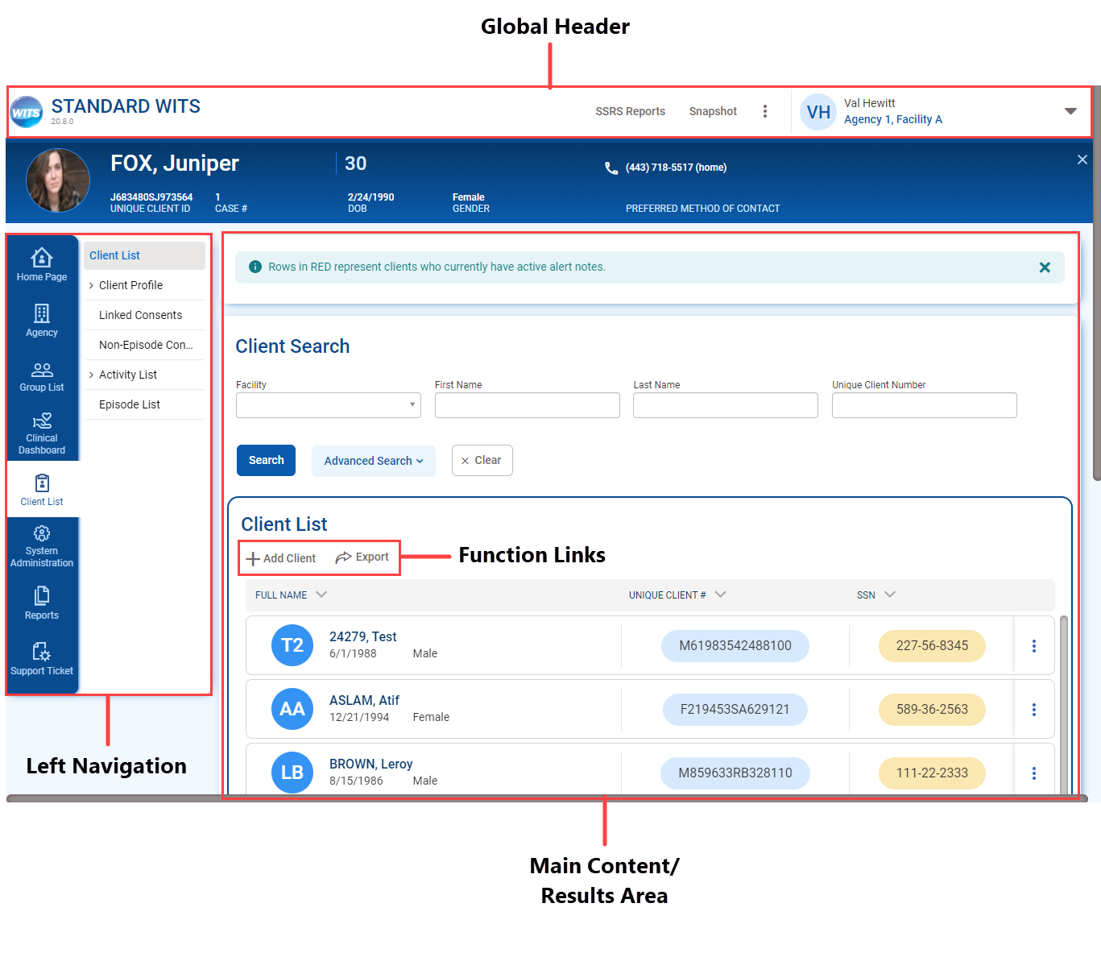
Figure 3-1: WITS User Interface Diagram

Global Header
This area contains information that helps the user know their current context in the system, which includes:
- Staff Member: Displays the name of the staff member currently logged into the system.
- Agency/Facility Location: Displays the Agency name and Facility name currently selected.
The Global Header also includes additional information and functionality, as shown in Figure 3-2: Global Header Features.
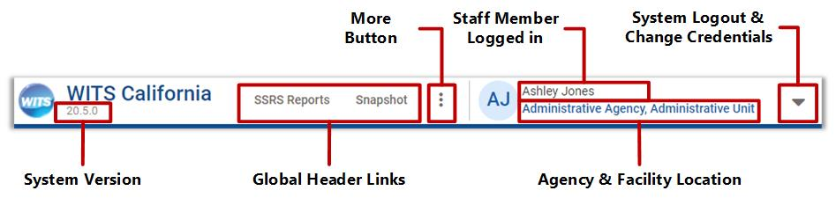
Figure 3-2: Global Header Features
When clicking the ellipsis, the list will expand with additional options.
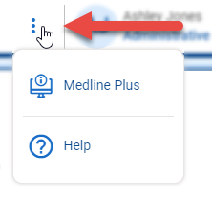
Figure 3-3: More Button in Header
When selecting the up arrow, the list will appear to let users change credentials or to log out of WITS.
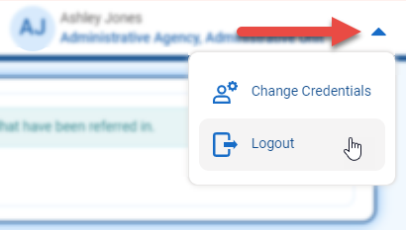
Figure 3-4: System Log out and change credentials

Client Header
If you are working with a client and have the client’s “file” open in the system, this is referred to as, “being in the context of a client.” Your top navigation will then display client context information. This information includes the Client Name, Client Photo, Unique Client Number (UCN), and Case Number if you are within the client’s activity list.
- Client Photo: Photo from Client Profile, if one is uploaded. If not, will display the client’s initials.
- Client Name: First and last name of client from the Client Profile.
- Unique Client Number: WITS generated Unique Client Number and Case Number.
- Demographics: Displays the client’s date of birth, age, and gender.
- Preferred Method of Contact: The listed preferred method of contact on the Client Profile page.
- Close Button: When this button is clicked, the system returns to the Client Search screen, just like the current functionality.
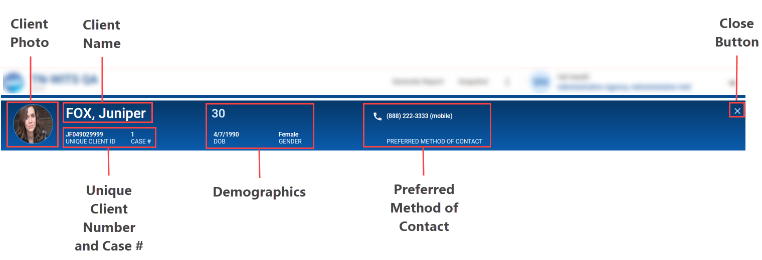

Figure 3-5: Client Context Diagram

On page scroll, the larger ribbon collapses to this smaller ribbon. Scroll back to the top of the screen to see the full header.
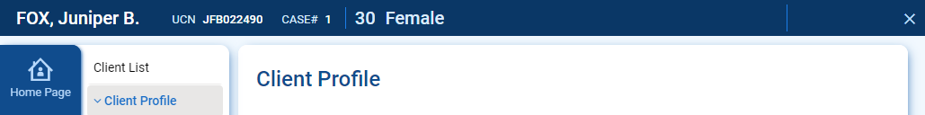

Left Navigation Menu
WITS has been designed to follow common behavioral health service workflows. As a result, when using the left navigation (menu), you will note that most of the modules and screens have been logically organized in a manner that makes sense to many Clinical Staff, Case Managers, and Administrators. The left navigation menu now displays icons for each module.

Home Page | Capacity List  (Wait List) | Agency | Group List
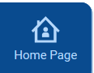 |  |  | 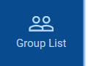
Authorization Dashboard | Residential Unit Dashboard | Residential Unit Management | Clinical Dashboard
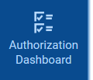 | 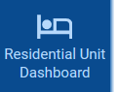 | 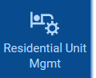 | 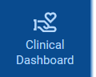
Client List | System Administeration | Reports | Support Ticket
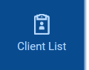 | 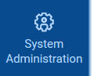 |  | 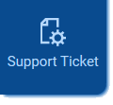
Figure 3-6: Left side navigation icons
- Hover: When a menu item is hovered over, the cursor will change to a hand, and the background color changes from dark blue, to a lighter blue.
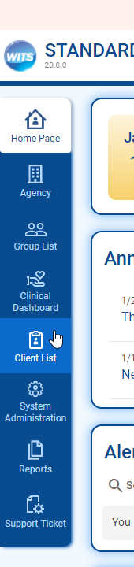
Figure 3-7: Hover Over Left Navigation Menu
- Select: Clicking the desired menu item will change the background color to white, and in most cases, the left menu will expand to display additional menu options available for that module.
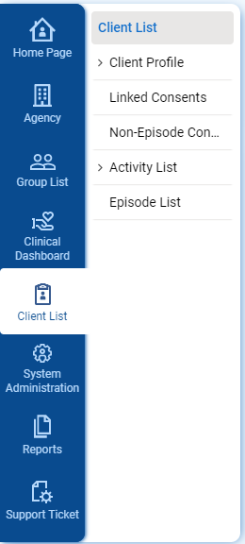
Figure 3-8: Left Navigation Bar with Expanded Menu
- Collapse Submenu: To hide the submenu, click the icon on the left navigation menu for the current module. This will free up additional space on screen.
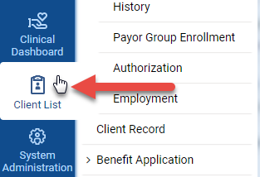
Figure 3-9: Click Left Menu Icon to Close Submenu
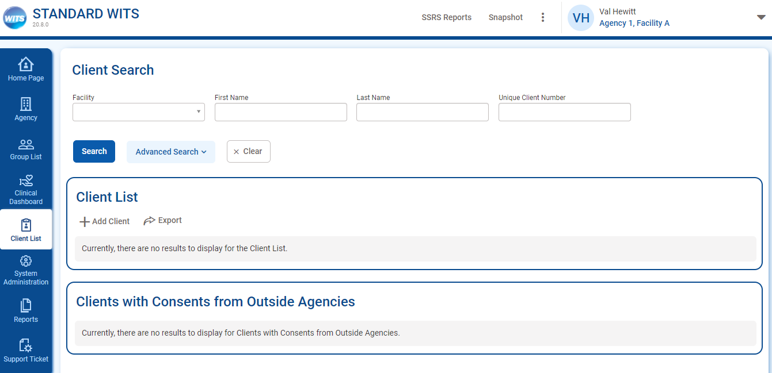
Figure 3-10: Screen with Left Menu Collapsed
- Submenu: When the left navigation bar is expanded to show the submenu, the selected submenu location is shown with a gray background and blue text. If a submenu item includes (>) before the name, that section can be expanded to display additional menu items.
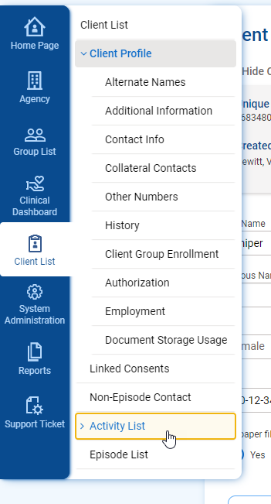
Figure 3-11: Submenu Sections

- Submenu Display: When users are working elsewhere on screen, the submenu names may be cropped to save space on screen. When users mouse over the submenu, the submenu will expand to show the full names of submenu items.
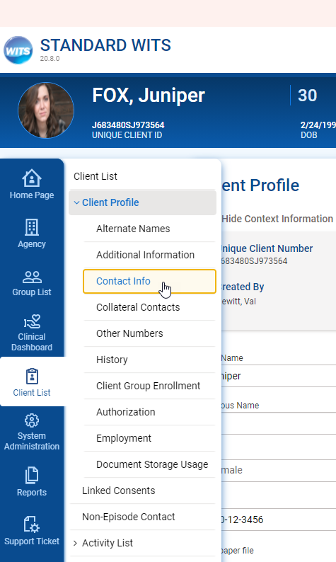
Figure 3-12: Hover over sub menu to expand

Navigating Through Screens
Screens with multiple sections will include Back and Next buttons. At the beginning of each section, the Next button will be active, and the Back button will be inactive. Both Back and Next buttons will be active if there are screens before and after the current screen. At the end of section, the Back button will be active and the Next button will be inactive.
Figure 3-13: Back and Next buttons

Users can also navigate through screens with multiple sections by clicking on the sub menu of on the left side navigation.
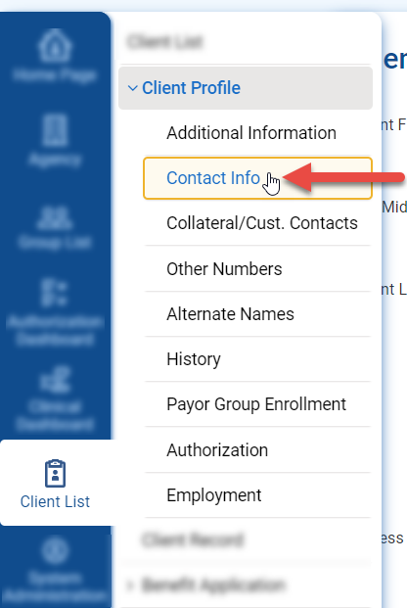
Figure 3-14: Left Side Navigation Sub Menu Navigation

Function Links
If the screen allows you to perform certain actions, such as Add or Export, the functions appear below the Section Header. A hand icon will also appear when your cursor floats over the action item, reminding you that you can click. Hovering over the link will turn the link blue.

Figure 3-15: Function link for Add Client

Types of Screens
The main area of the screen will constantly change as you progress through your workflow. Typically, you will first see one of these screens:
- Login Screen: Log into the software from your browser.
- Search Screen: Use the search fields to help find information already entered in WITS.
- List Screen: Displays a list of information/records; search results are also displayed in a List Screen.
- Profile Screen: Use the fields to enter data then click the Save button.

Login Screens
The login screens are easily identifiable with the type of site labeled as well as different color scheme.
Login screens now display a welcoming background scene when users enter their credentials. We have also moved the instance logo out of the login box to make it more prominent, and move the login button within the bottom bar for easier user experience.

Production
The login screen for the Production environment will have a blue bar at the bottom of the login section.

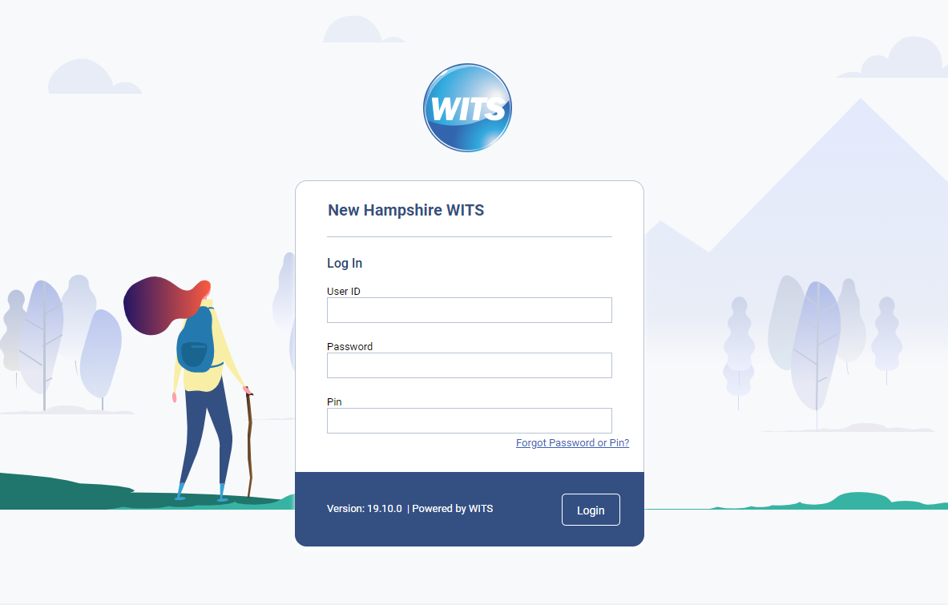
Figure 3-16: Production login screen

Training
The login screen for the training environment will have a teal bar at the bottom of the login section.
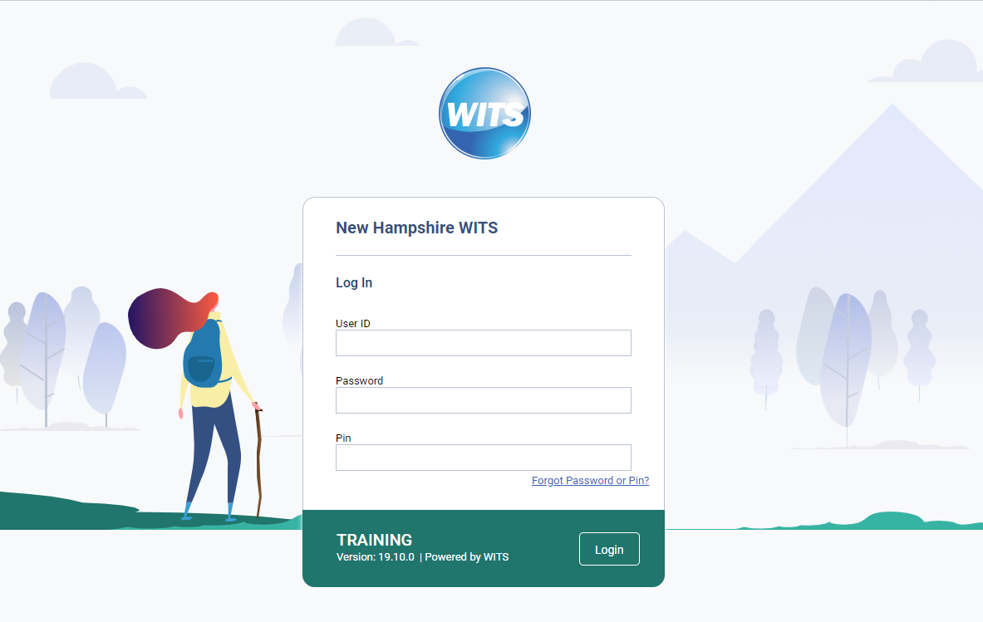
Figure 3-17: Training login screen

UAT
The login screen for the UAT environment will have an orange bar at the bottom of the login section.
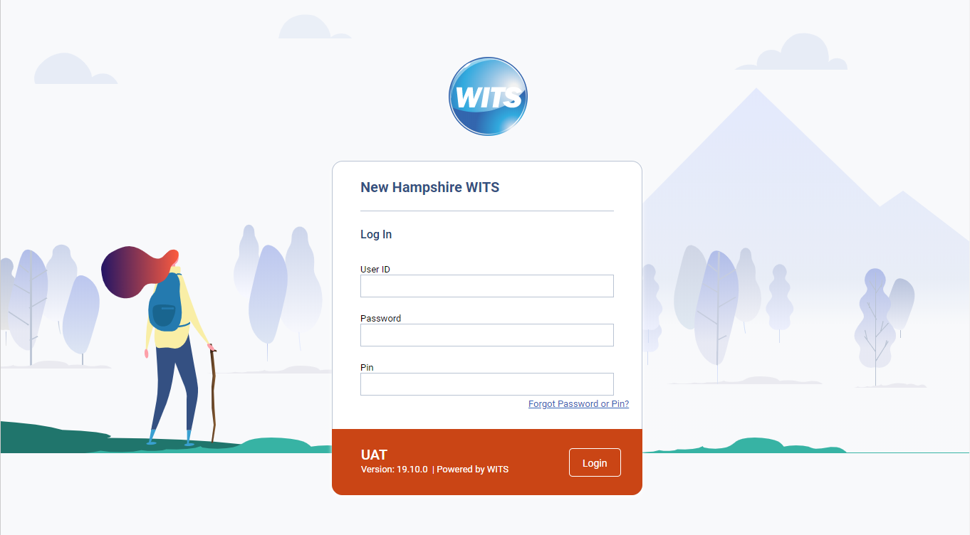
Figure 3-18: UAT login screen

QA
The login screen for the QA environment will have a purple bar at the bottom of the login section.
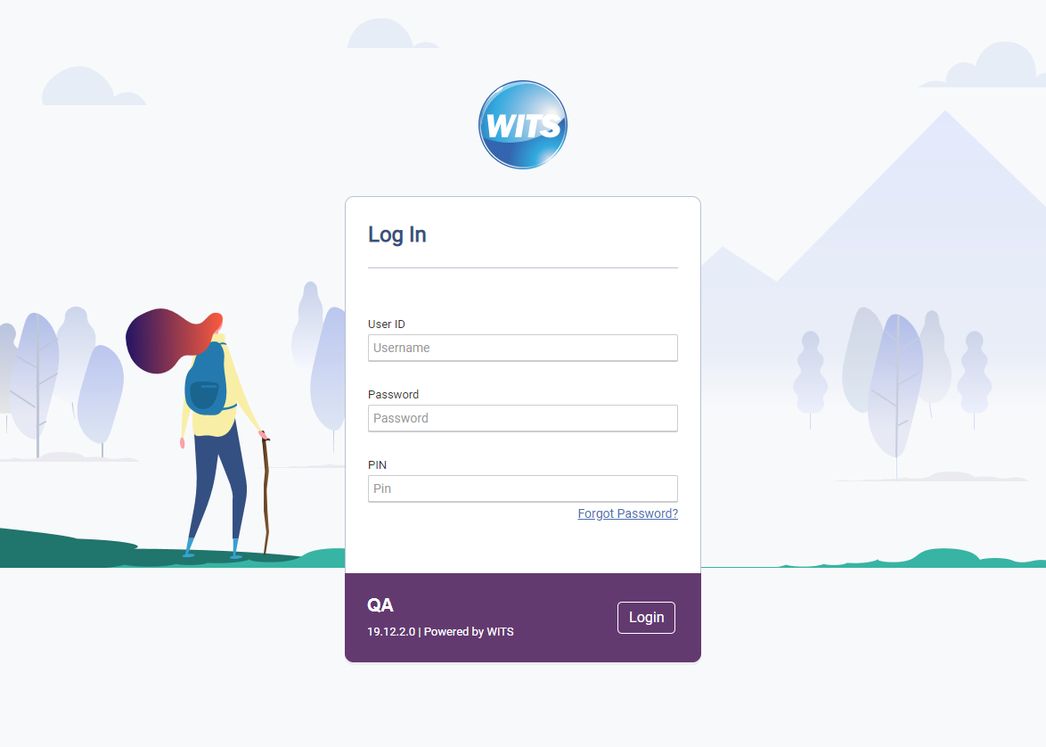
Figure 3-19: QA login screen
The WITS Warning screen will have the color bar for the environment below the warning.
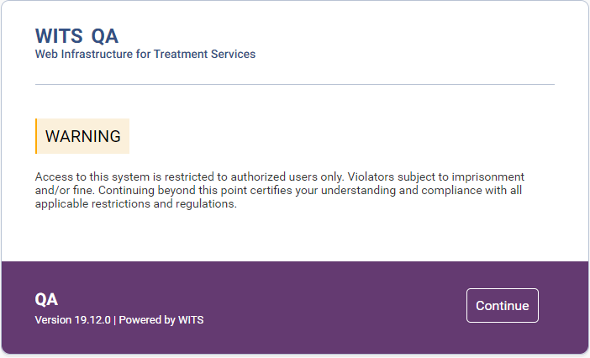
Figure 3-20: WITS Warning Screen

Home Page
The Homepage is the landing page when entering into WITS. Announcements, Alerts and Schedule are displayed for users to quickly see important information.
Key Change(s):
- New date and Hello section
Legacy UI
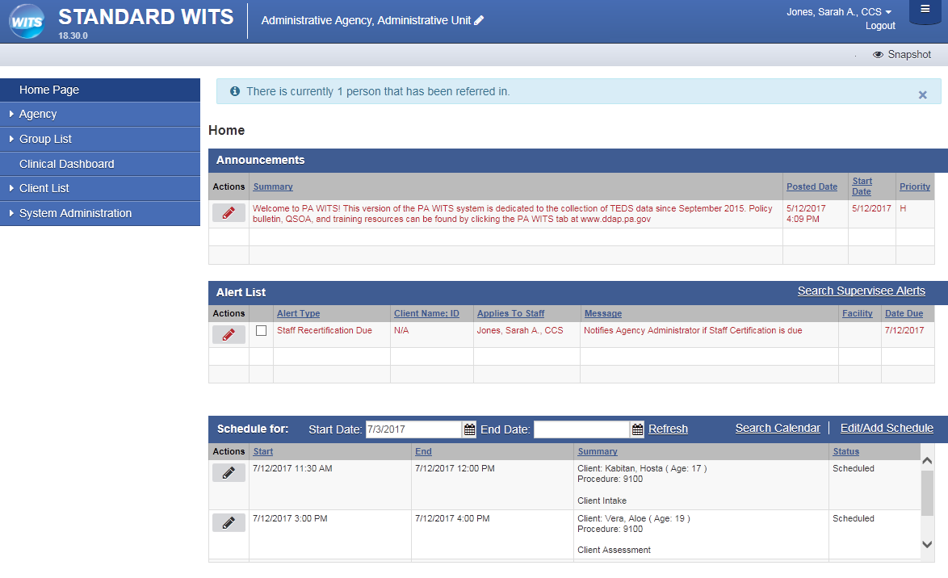
Figure 3-21: Legacy UI Home Page
New Design:
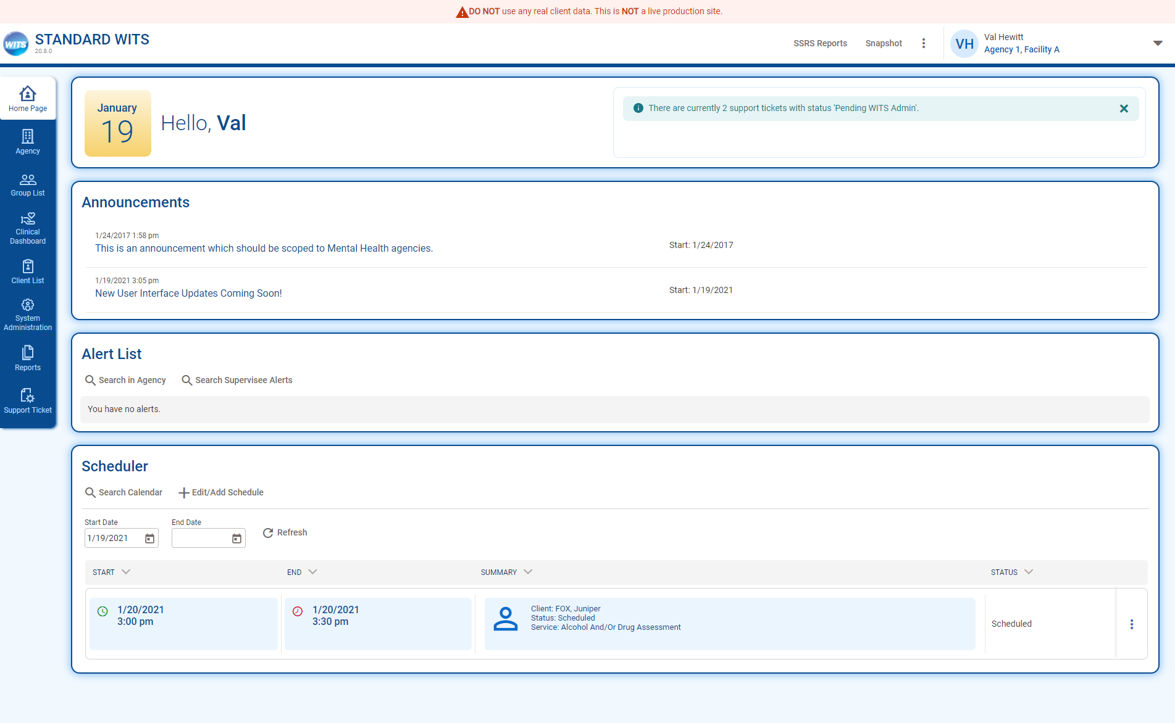
Figure 3-22: New Homepage UI

Search Screen
Key Change(s):
- Placement of buttons now on left side
- The “Go” button has been replaced with “Search”
- Search fields are no longer compacted on screen
- Field names are located above the field
- An “Advanced Search” button is available, which displays all available search fields on the client list
- Pagination on search results

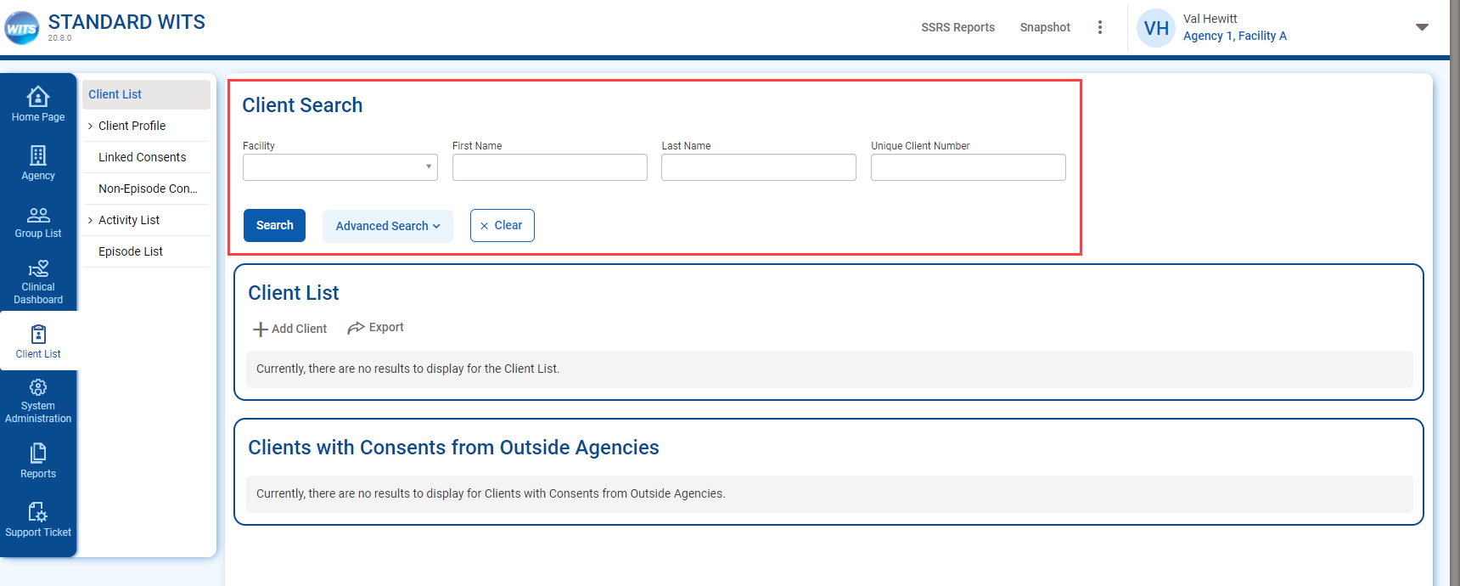
Figure 3-23: Client Search Screen
Advanced Search
On the client list search screen, users will notice search fields are no longer compacted on screen and fields are now displayed in four (4) columns instead of two (2). In addition, default search fields have been defined which are visible when the user access the screen. Customers can request FEI change the default search screens to other fields in your instance. An Advanced Search button is available to display all search fields.
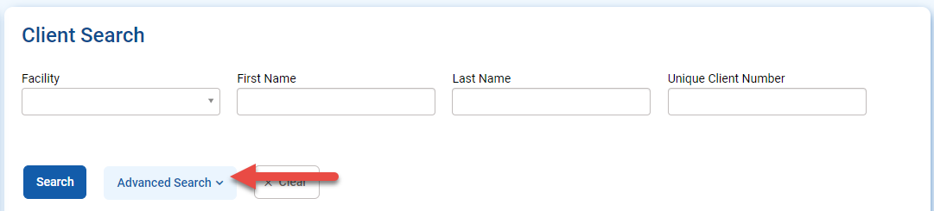
Figure 3-24: Client Advanced Search Button

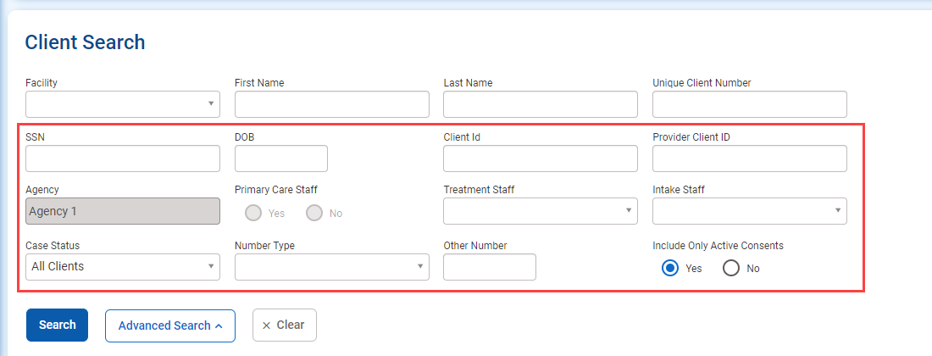
Figure 3-25: Advanced Search
Pagination
When search results are rendered, the results list will paginate. In Legacy WITS, all results appeared on the page, and sometimes required extensive scrolling. The results will now paginate, with 50 results per page. Pagination navigation will appear at the top and the bottom of the search results box.

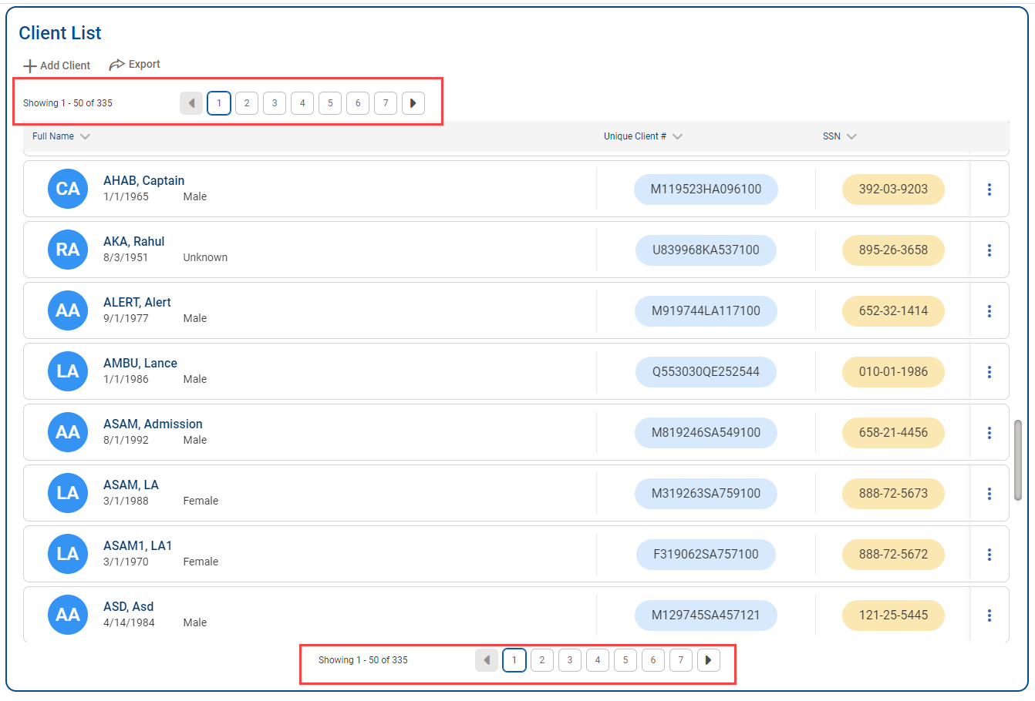

List Screen
List screens are located below Search screens, and can also be in other areas, such as the Activity List.
Key Change(s):
- Table sorting represented by arrows
- “Add” (+) icon added to section header buttons
- On List screens, the Actions column is now located on the right side
- Actions icon is now a vertical ellipsis, not the pencil icon
- On action rollover, action links are vertically stacked

Section Headers
For headers that are tables, an “add” (+) icon has been included to section header buttons that contain the word “Add”, “Start”, “Create”, or “New”. When scrolling through a list on screen, the list header will remain displayed at the top.
Legacy UI:
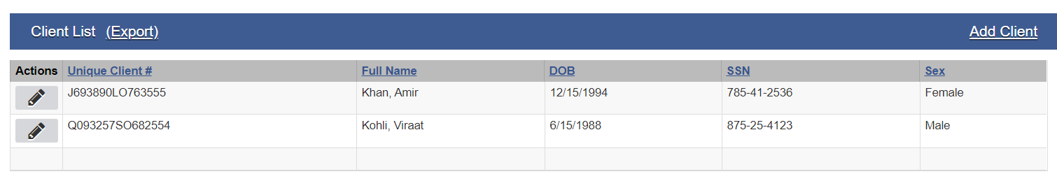
Figure 3-26: Client List Legacy UI
New UI:
For the client list, the first column is combining First, Last, DOB and Gender is same cell with the client name. ID fields have accent colored background. If a client picture is uploaded then it would display, otherwise it displays the initials of the client.
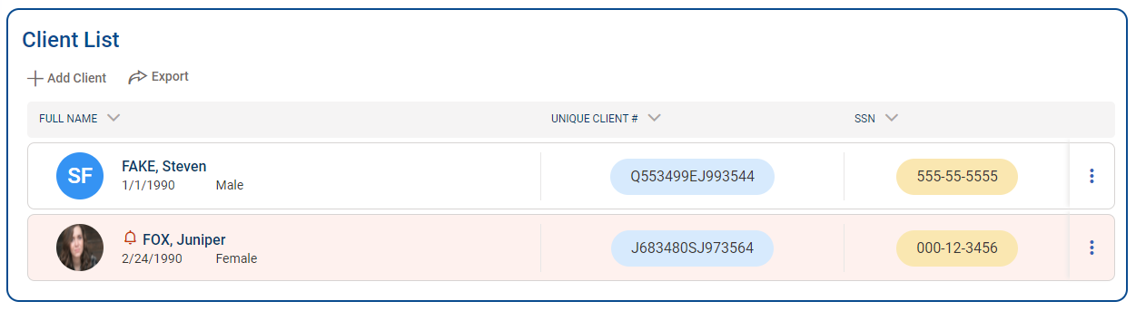
Figure 3-27L Client List New UI

Navigating with List Results
Key Change(s):
- On List screens, the Actions column is now located on the right side
- Actions icon is now a vertical ellipsis, not the pencil icon
- On action rollover, action links are vertically stacked
Legacy UI:
To Navigate within the updated Client List screen, rows are highlighted when cursor moves over the row. If a client’s row is pink, that means that the client has an alert on their record.
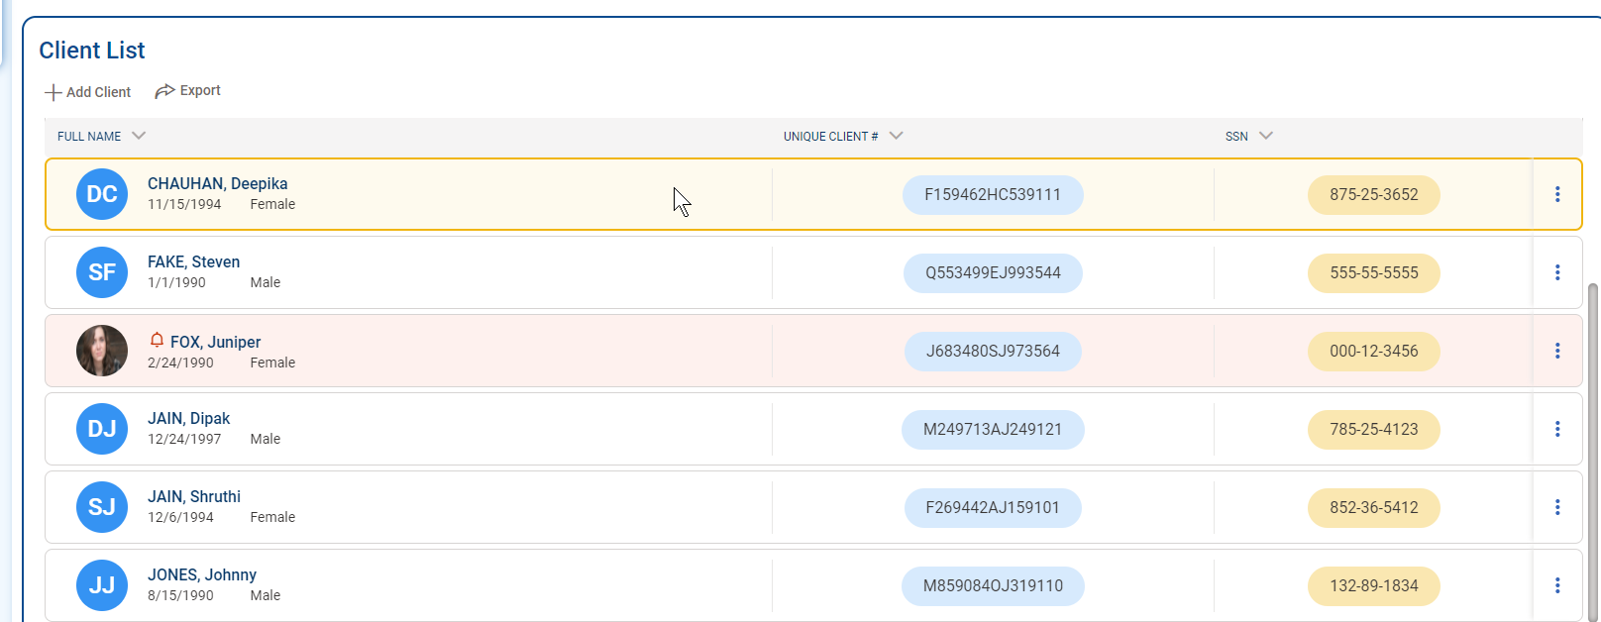
Figure 3-28: Highlighted Row when hovering on client row
To interact with an item displayed in a list, point to the actions icon to view a menu with available links. When pointing to an action, the cursor becomes a hand when you hover over the action text.
To select an action, click the name be taken to that screen.
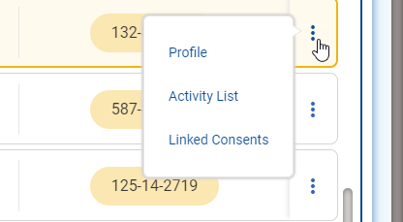
Figure 3-29: Hover Over Menu Icons in Client List
All expanded list icons have the menu icons on the right side of the screen.
Legacy UI:
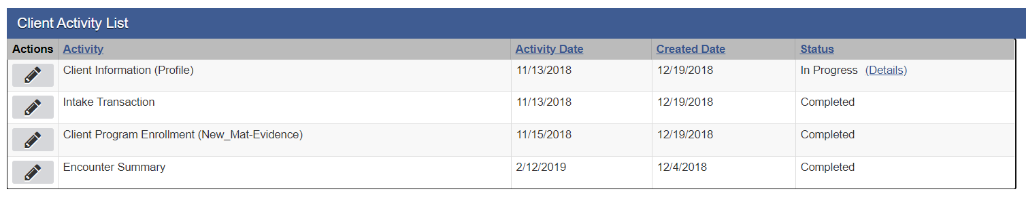
Figure 3-30: Legacy UI Client Activity List
New UI:
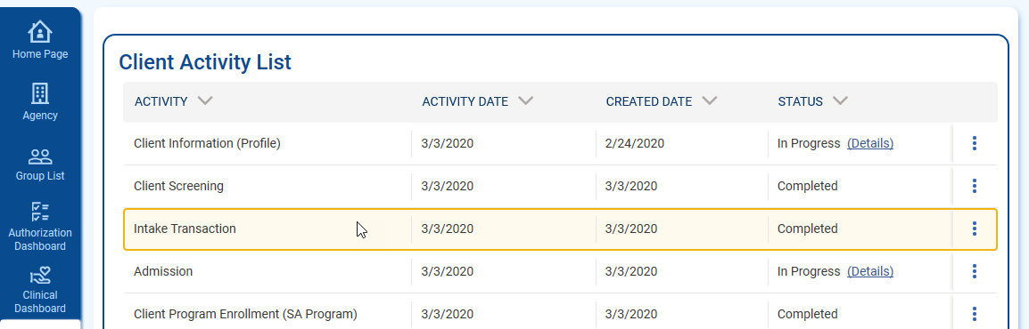
Figure 3-31: Client Activity List New UI

To access the Client Activity Menu (formerly the pencil icon in the legacy UI) hover over the ellipsis icon.

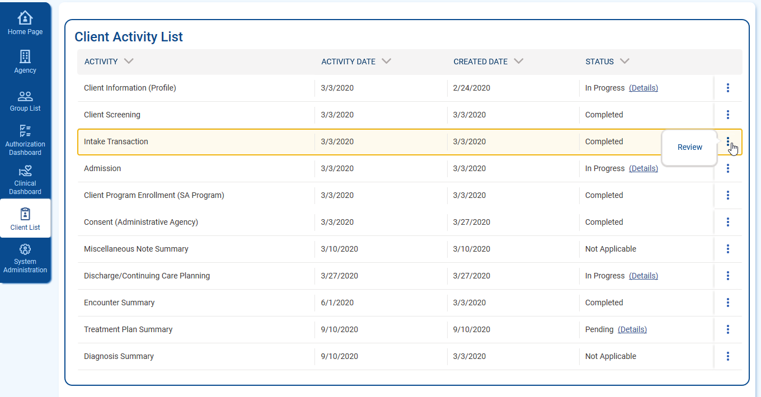
Figure 3-32: hover Over Menu Icon Client Activity List

Profile Screen
The profile screens show basic information about the client, and information about encounters recorded.
Key Change(s):
- Placement of buttons is now located on the left side
- Administrative Actions highlighted and now on left side above buttons
- Field Labels on top of field
- Updated fields and buttons (see sections 3.5 and 3.6 for more information)
- Ability to add client photo
- Required fields have an orange bar on the left

Client Profile
Legacy UI:
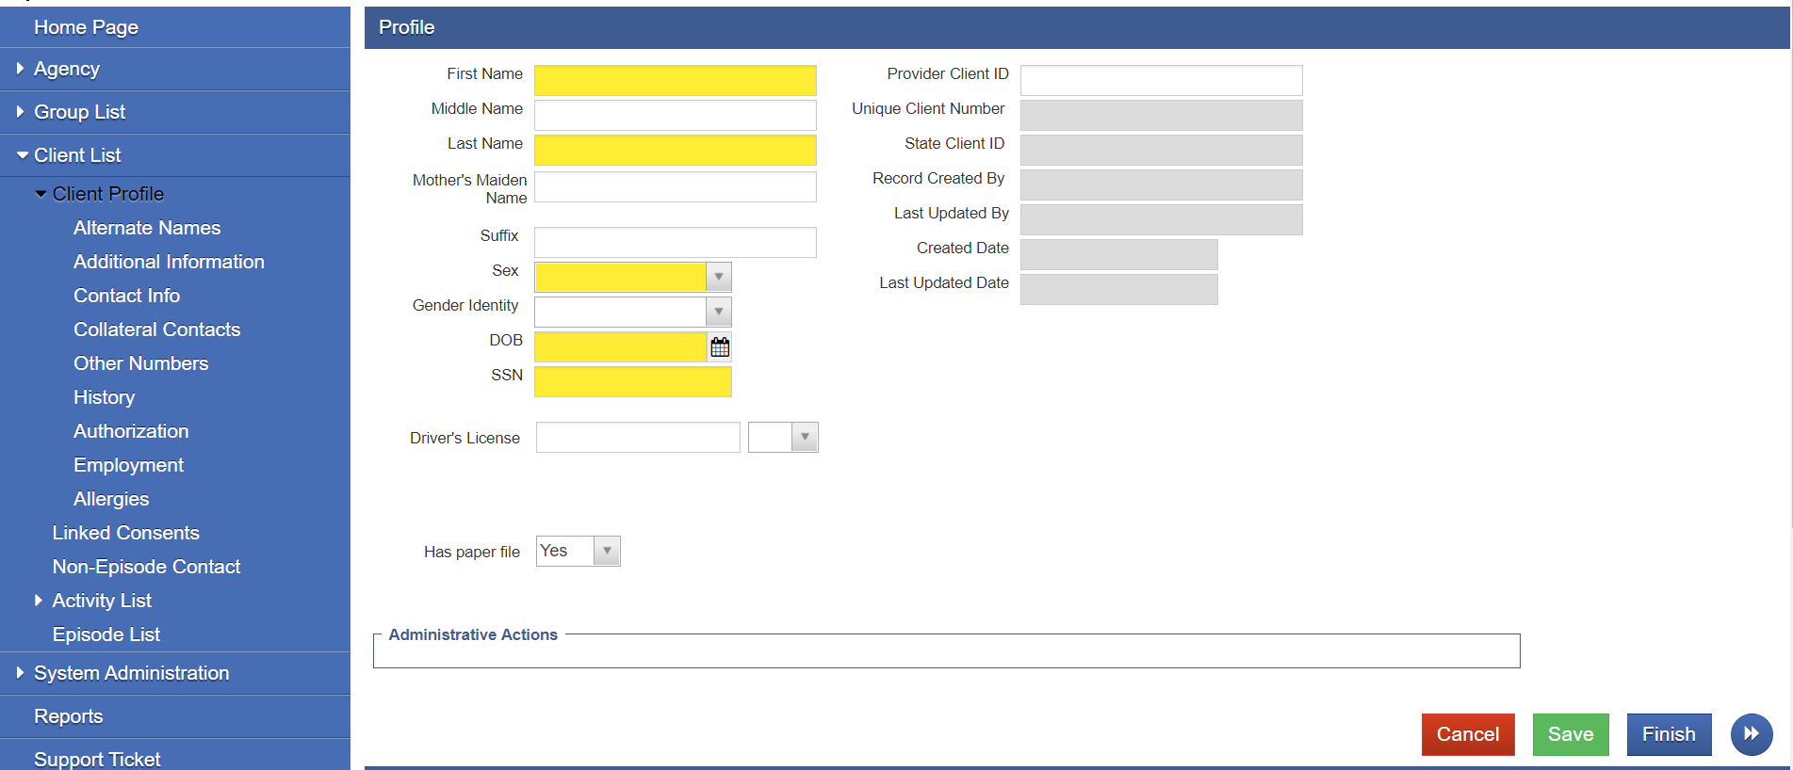
New UI:
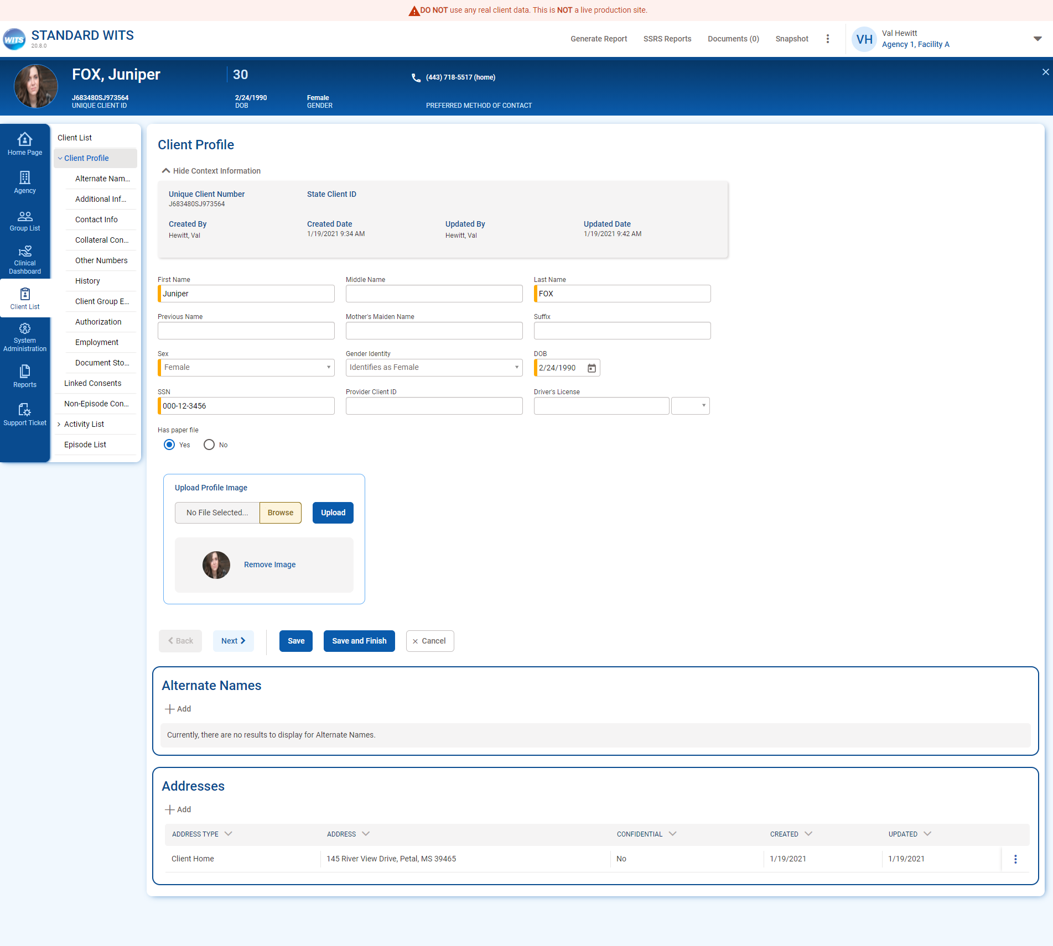
Figure 3-33: WITS Client Profile Screen

Client Profile Photo
WITS now has the ability to store and show client profile photos. To add a client profile photo, on the Client Profile screen, In the Upload Profile Image section, click the Choose File button to open the file picker, and once the file is selected, click upload.
Once uploaded, the client profile will appear on the client profile page, in the client header, and the Client Search results list.
Figure 3-34 Client Photo in Header
The picture can be changed or deleted on the client profile. To delete the picture, click the Remove Image button. To upload a new picture, click the Browse button, select the picture from your desktop, and click the upload button.
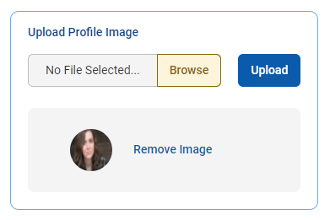

Encounter Screen
The Encounter Screen is another type of a profile screen within WITS, and the new UI applies to all profile screens.
Legacy UI:
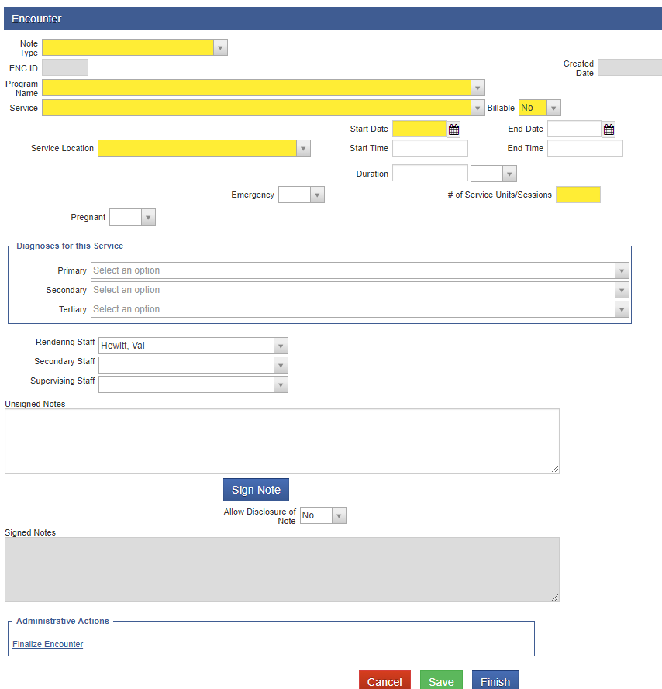
New UI:
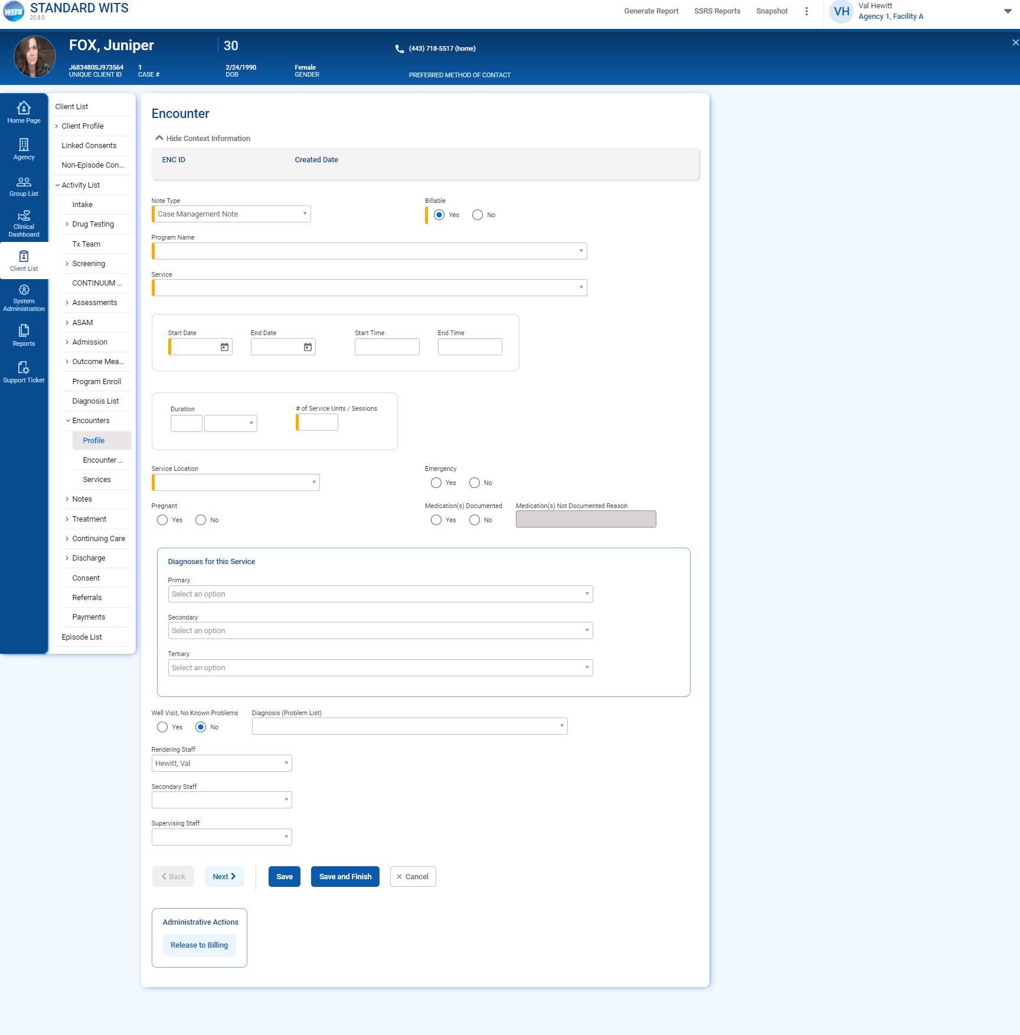

Enhanced Archictecture (EA) Screens
The Enhanced Architecture (EA) screens were built after the legacy screens. They have a more updated look, and therefore did not need as many updates. These screens were updated to the new UI, including the changes to required fields, drop down choices and mover boxes.
In addition, the left side menu will now stay open when accessing the EA screens.

Staff Members
Key Change(s):
- Table sorting represented by arrows
- “Add” (+) icon added to section header buttons
- On List screens, the Actions column is now located on the right side
- Actions icon is now a vertical ellipsis, not the pencil icon
- On action rollover, action links are vertically stacked
Legacy EA:
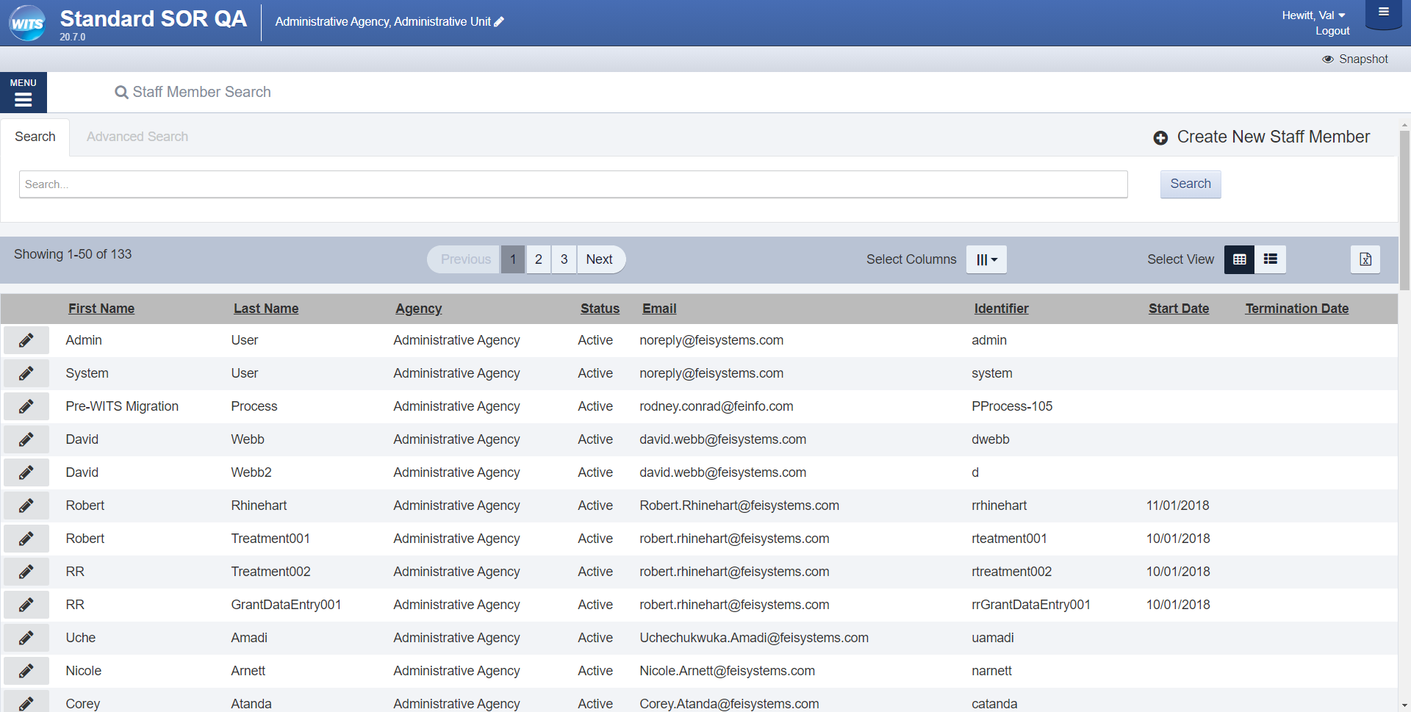

New UI:
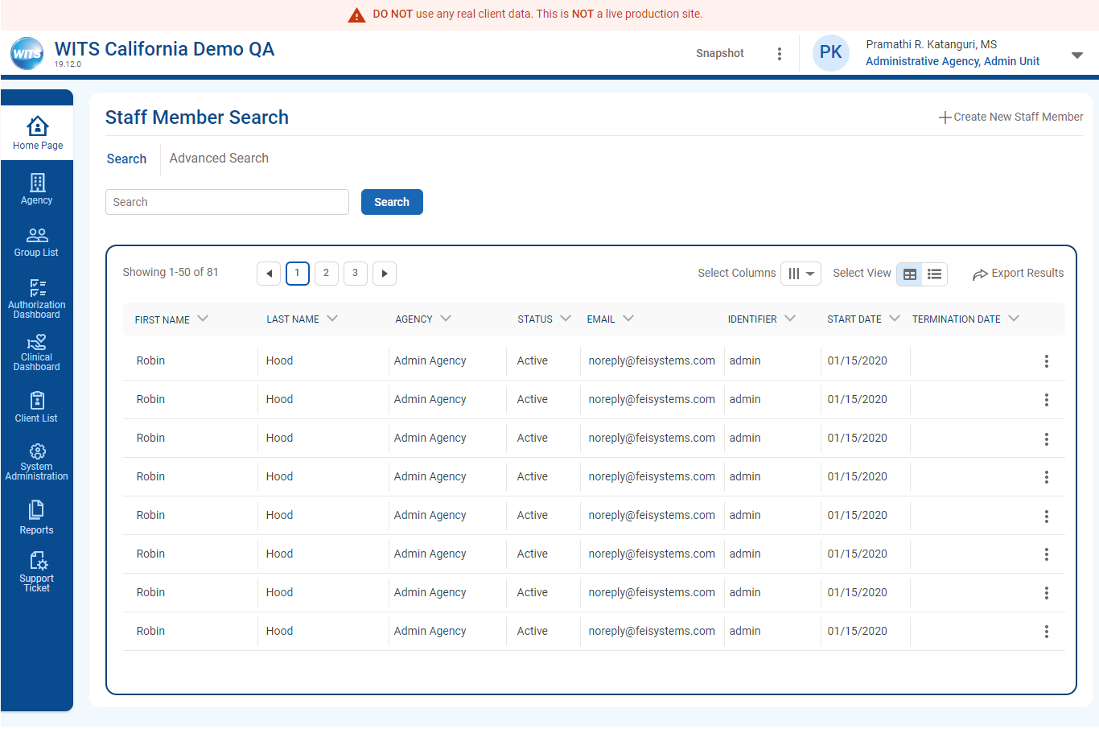

Staff Member Workspace
Key Change(s):
- Styling updated to new UI
Legacy EA:
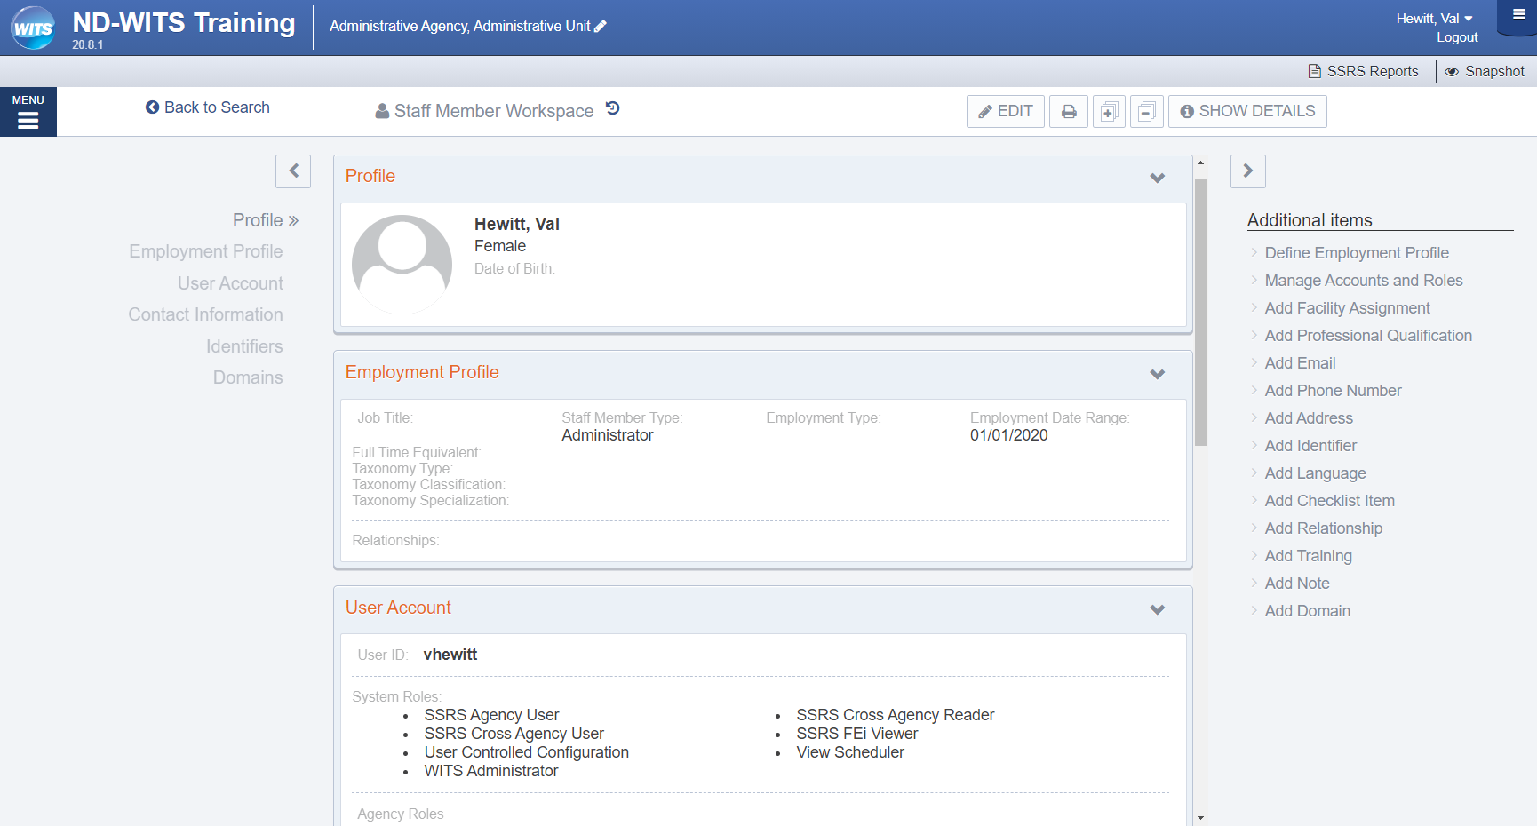

New UI:
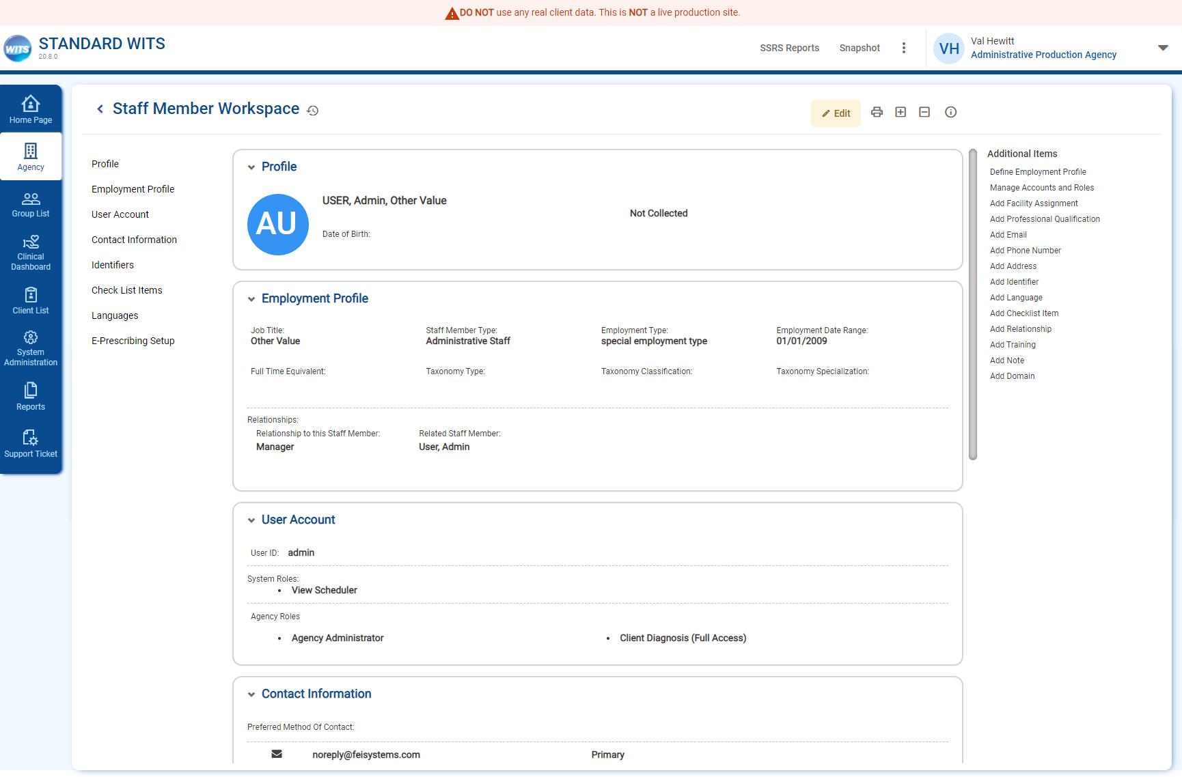

EA Treatement Plan
The EA Treatment Plan

Treatment Plan Screen
Key Change(s):
- Updated Styling

Legacy EA:
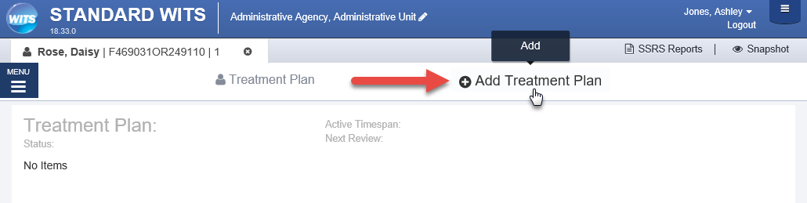
New UI:
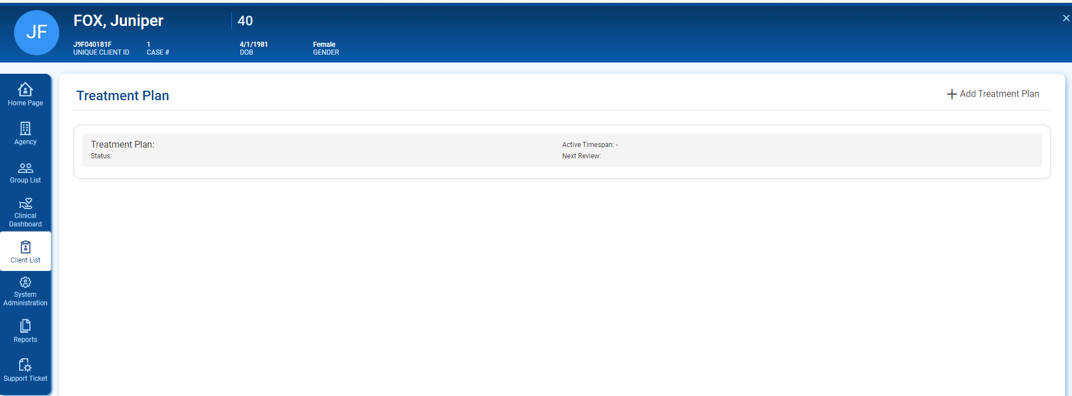

Add Treatment Plan Pop-up
Key Change(s):
- Updated Styling

Legacy EA:
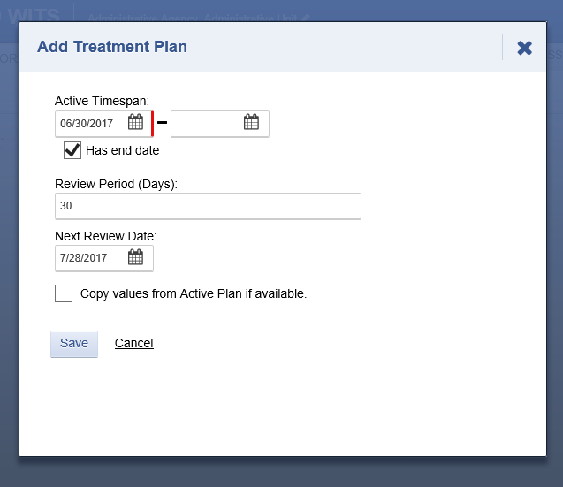
New UI:
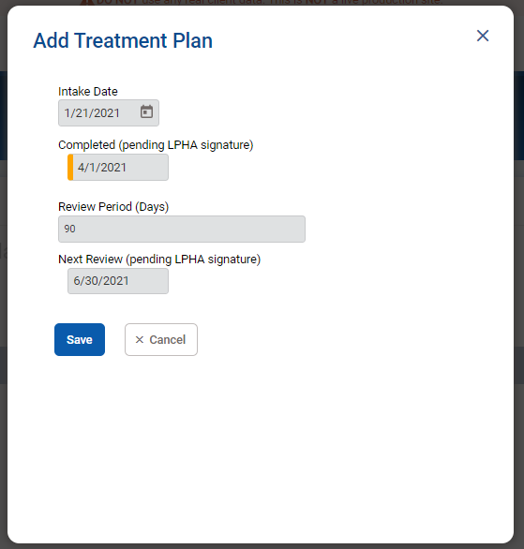

Treatement Plan
Key Change(s):
- Updated Styling

Legacy EA:
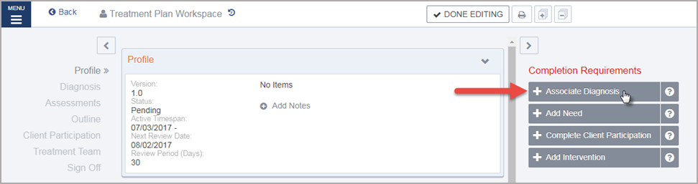

New UI:

Completed Treatment Plan
Key Change(s):
- Updated Styling
- View Button moved from the right side to the bottom of the Treatment Plan.
Legacy EA:
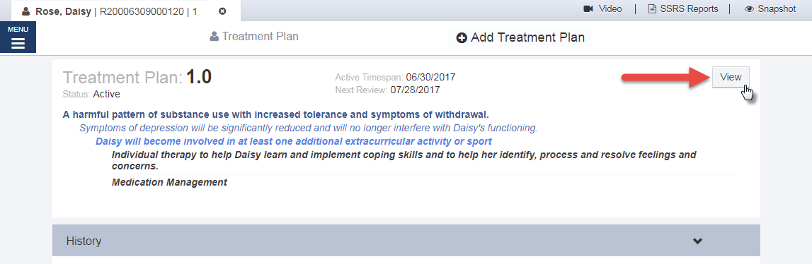
Legacy EA:
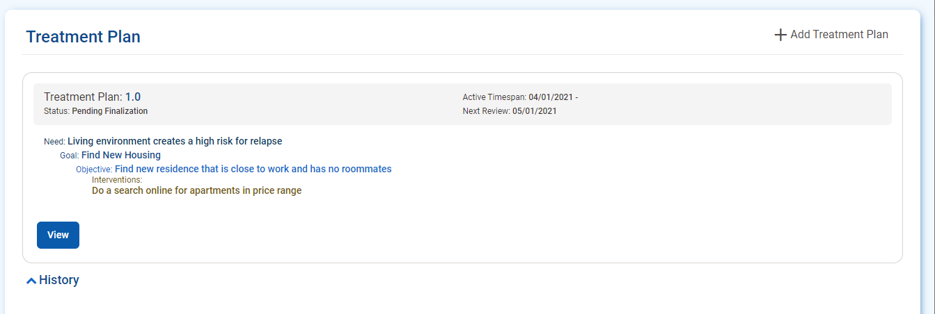

Grant Management Dashboard
The grant dashboard is a new screen for SOR customers. The dashboard shows a snapshot of GPRA Data, including GPRAs by Gender, by races, and GPRA follow up compliance. Each of the pie charts on the screen can be filtered by Grant, Agency, and date range.
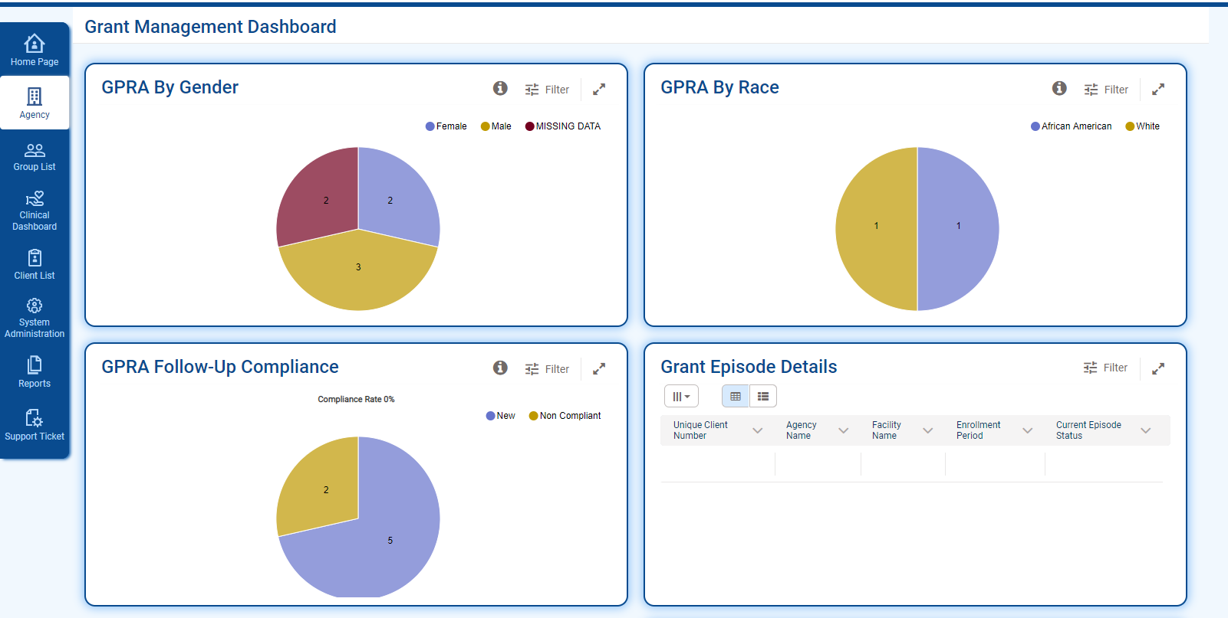

Alerts/Notifications
Alerts and Notifications will appear at the top of the WITS Screen, below the header.
Legacy UI:
Table 2: Legacy System Alerts
System Alert/Notification | Description
 | Informational: This notification message informs users that something has occurred.
 | Warning: This notification message warns the user that entered data falls outside of a certain parameter. The record can still be updated.
 | Warning Elevated: This type of notification is a higher warning message that needs to stand out more.
New UI:
Table 3: New UI System Alerts Styling
System Alert/Notification | Description
 | Success: This notification informs the user that their action was completed.
 | Informational: This notification message informs users that something has occurred.
 | Warning: This notification message warns the user that entered data falls outside of a certain parameter. The record can still be updated.
 | Warning Elevated: This type of notification is a higher warning message that needs to stand out more.
 | Error: This notification message indicates an error on the screen. WITS will not allow the user to leave or save the page until the stated error is addressed.

Buttons
Key Change(s):
- Colors have been updated to blue theme
- Cancel button placement
- Finish is now “Save and Finish”
- Back and Next buttons updated with text.

Save, Save and Finish
Legacy UI:
Figure 3-36: Legacy UI Cancel, Save and Finish Buttons
New UI
Figure 3-37: Save, Save and Finish and Cancel buttons

Administrative Actions
Legacy UI:
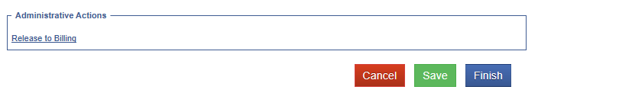
Figure 3-38: Legacy UI Administrative Actions
New UI:
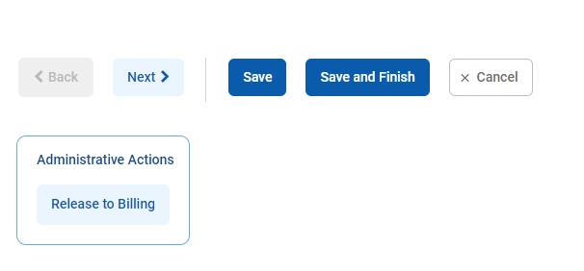
Figure 3-39: New UI Administrative Actions

Back and Next
The Back and Next buttons clearly indicate additional screens for the user to progress through.
Legacy UI:
Figure 3-40: Legacy UI Back and Next Buttons
New UI:
Figure 3-41: Back and Next buttons
When hovering over buttons with your mouse, the selected button will change in appearance. The table below illustrates the change:
Legacy UI | Button | Selected Button | Functionality
 |  |  | Saves data entered and remains on the current screen.
 |  |  | Saves data entered and returns to the section start page.
 |  | 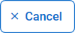 | Cancels the current action and returns to the previous screen.
 | 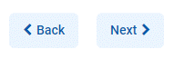 |  | Navigate through the screens in each section (left and right arrow buttons).
 |  |  | Moves data from one mover box to another (mover buttons).
 |  | 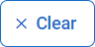 | Clears all criteria from search fields.
 |  |  | Run the search screen using the criteria entered in the search fields.
 |  |  | Expand search options

Text Link
Functionality: Text links can be blue or grey, depending on placement and prominence needed. By default, the link is grey, unless the link is located within the body of a form. When you hover over a link with your mouse, the link will turn blue.
Key Update:
- Plus (+) button added to the left of the link for any add/create action link
Legacy UI:

New UI:

Fields
Key Change(s):
- Label placement for each field is now located above the field
- Required for Completion and Required for Save indicators have changed to the left side
- Yes/No fields now represented as Radio Buttons

Text Inputs
Functionality: Input text into a field.
Key Change(s):
- Label placement for each field is now located above the field
- Required for Completion and Required for Save indicators have changed to the left side
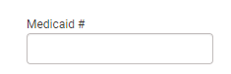

Required Fields
Key Change(s):
- Easier to distinguish between fields required to save versus required for completion
- When a field is focused, it becomes a bold outlined in blue; it is more prominent than before.
Required to Save: Solid bar on left side
- Indicates items required to save the screen.
Required for Completion (Reporting required): Striped bar on left side
- Indicates items required to be in a completed status (i.e., State required fields), but are not required to save the screen.

Field Types

Textbox
Functionality: Enter text into the field.
Key Update(s):
- Requirements are in a bar on the left side of the field
The table below outlines the changes to text box fields; however this pattern is the same for all field types.
Description | Required to Save | Required for Completion
Base |  | 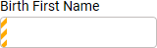
Focus (when the field is clicked)
Filled In
Validation Error (empty)

Select Option (drop-down)
Functionality: Select one option from drop down box.
Key Changes(s):
- Requirements are in a bar on the left side of the field

Description | Required to Save | Required for Completion
Drop down | 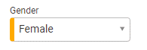 | 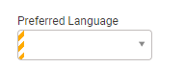

Radio Buttons
Function: Select one option.
Key Change(s):
- Yes/No fields are now represented by radio buttons
- Requirements are in a bar on the left side of the field
- To clear the field, select the option again
Description | Required to Save | Required for Completion
Base Radio Buttons | 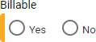 | 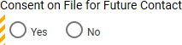
Radio Buttons Selected | 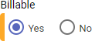 | 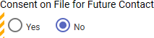

Multi-Select List Box/Transfer Box
Functionality: Select multiple options from one mover box to another.
Key Update(s):
- Requirements are in a bar on the left side of the field
- Updated look of mover buttons
Depending on what browser you are using, the scroll bar appearance differs.
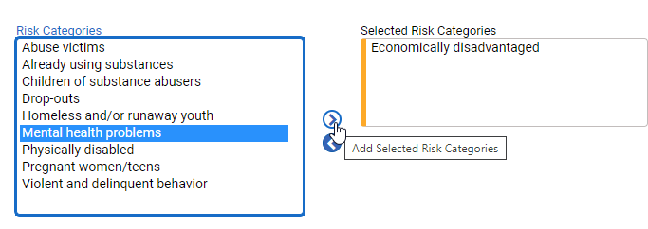
Figure 3-42: Multi Select Box Required to Save Question
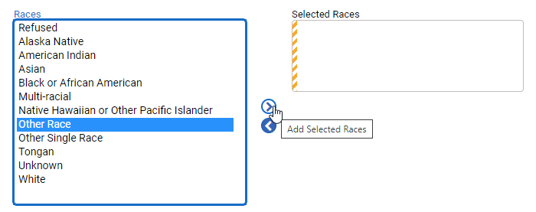
Figure 3-43: Multi Select Box Required for Completion

Time Input
Functionality: Enter the time.
Key Change(s):
- Requirements are on the left side of the field

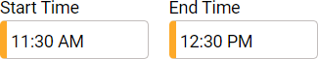

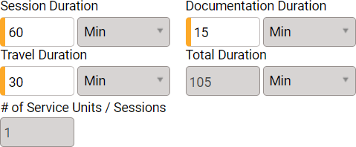
Figure 3-44: Time Input Fields

