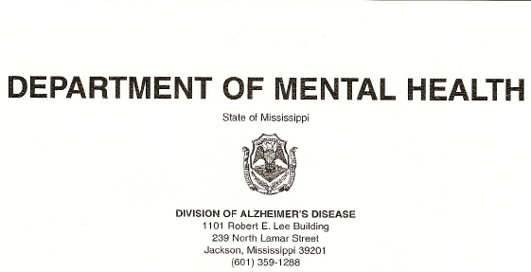

June 1, 2013

Dear Prospective Event Host,

As you may know, “Shaping the Future”, the 14th Annual Conference on Alzheimer’s Disease and Psychiatric Disorders in the Elderly is scheduled for August 14 – 16, 2013 at the MSU Riley Center in Downtown Meridian, MS. This is the only statewide conference on Alzheimer’s disease and has averaged over 500 attendees the past 4 years. We are excited about being back in Central Mississippi!

We have a fantastic opportunity to bring “Rock –N-Roll AD”, a musical comedy about the challenges of Alzheimer’s disease to Mississippi. The play was written by Mr. Avrum Krause and is presented by Time of Your Life Players from Chicago, IL. Members of the troupe range in age from 54 years old to 72 years old! This event is scheduled for Thursday, August 15, 2013 at 7:00pm.

The play is designed to serve as a unique Alzheimer’s Awareness activity evoking dialogue with the cast and crew immediately following the production. We would like to make this open to both Conference Attendees and the public free of charge. In order to do this, we are seeking additional funding for this event. We will accept donations from attendees at the door, but need some help to offset initial costs. Event hosts will be recognized with signage outside the Theater and on the playbill. Attached is an article from the Chicago Tribune about the play.

We appreciate your consideration to host this event. Please feel free to contact me with any questions via e-mail Kathy.vancleave@Dmh.state.ms.us or
cell: 601-408-5225. Again, thank you for your consideration.

Sincerely,

Kathy Van Cleave, LMSW, LCMHT
Director, Division of Alzheimer’s Disease
MS Dept. of Mental Health
TRIBUNE VOICES
Alzheimer’s musical touches chord for troupe, audiences
As a subject for a musical comedy, Alzheimer’s disease can be a tough sell.
Even Avrum Krause, director of the Time of Your Life Players, who came up with the idea of writing a musical comedy about a rock guitarist who develops early onset Alzheimer’s, had doubts.
“I thought, ‘I have to be absolutely crazy,’ ” he said.
When Krause contacted Melanie Chavin, vice president of program services for the Alzheimer’s Association’s Greater Illinois Chapter, about the show, “I looked at him like he was nuts,” she said.
She has come around. The Alzheimer’s Association chapter was so impressed with the show’s run this past fall that it encouraged the company to mount another run, which opened Feb. 27, and leads audience discussions after each performance.

But “Rock ’n’ Roll AD” has struggled to attract audiences. Several senior citizens’ groups that usually attend the troupe’s shows have not bought tickets to this one. It isn’t just the idea of a show about an illness. Audiences did not balk at Time of Your Life Players’ musical about a man who undergoes surgery for prostate cancer. It is this illness. Humorous treatment of Alzheimer’s? “Absolutely. The more upbeat, the better,” said Bob Hawley, 70. He was among a group attending last week’s show at the Chicago Cultural Center that had no problem with the concept. They were members of Without Warning, Rush University Medical Center’s support group for people with younger-onset Alzheimer’s and their families.
Their approach to having Alzheimer’s is to do their best to enjoy life anyway. “I could always gnash my teeth and burrow under the bed, but I’m not going to do it,” Hawley said.
For them, the show was a hit.

The song “Tuesdays at Two,” about an Alzheimer’s support group? True to their own experiences in a group. “Clinical Trial,” an ode sung by two women dressed as pills wearing T-shirts reading, “25 mg”? Seriously funny. They singled out the song “Diagnostic Test” as especially realistic. People in white coats pepper Roy, the protagonist, with so many neurological test questions — Who’s the president? Where’s your residence? / … Name this state! What’s the date? / Stack a block! Draw a clock! — that the sentences run together in a frustrating, impossible-to-answer whirl. “That’s what it feels like,” Hawley said. “You’re being bombarded.”

Alzheimer’s would seem a natural topic for the Time of Your Life Players. A troupe of actors age 55 and older — if you can make it up to the fourth-floor rehearsal space, they joke, you’re halfway into the troupe — they focus on issues of interest to older people. In some cases, literally. “I had gone through prostate cancer myself,” said Krause, who turned the experience into a show with a liberal dose of humor, including a song about a male nurse inserting the patient’s catheter. As for Alzheimer’s, all the cast members have had a family member who suffered from it. Electric guitarist Jim Casler’s father, aunt and grandmother died of it. That didn’t mean they wanted to be in a musical about it. “I was really skeptical,” said Michael Lieber, who plays several roles and the accordion. “A show about Alzheimer’s? I was afraid it would be a downer.” “I was embarrassed. I didn’t want to invite anybody,” said Annie Kontak, who plays Roy’s agent. “Alzheimer’s — it’s an old person’s thing. We don’t think we’re old.”
Larry Hazard, who plays Roy, was worried about the humor. “You don’t want people to think you’re laughing at them,” he said.

He stopped worrying when he read the lyrics by Lauren Krause, a speech pathologist and Avrum Krause’s wife. They were excellent, he said, and entirely good-hearted. Kontak saw that people attending the show were moved by it. When she finally invited some friends and neighbors, several of them cried.
She stopped being embarrassed. “I just got off it,” she said briskly. “It’s a really good entertainment, and people will learn something and see it isn’t so scary,” Avrum Krause said. “We demonstrate in our play how someone has dealt with this and continues on with his life. It’s a very upbeat show.”

And one that ended last week with the Alzheimer’s support group members taking to the stage to tell how they have continued with their lives.
“You exercise; you do activities; you do all the things you’re supposed to do; you do memory things,” Hawley said.
“And you forgive yourself for having what you have.”
The show was over, but the applause returned.
“Rock ’n’ Roll AD” runs through March 29 at Stage 773, 1225 W. Belmont Ave. For information, call 773-327-5252 or visit stage773.com . blbrotman@tribune.com

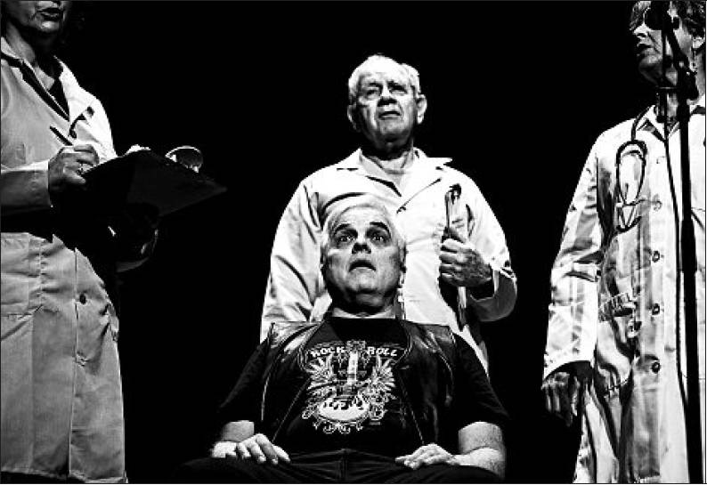
HEATHER CHARLES/TRIBUNE PHOTO
Roy, center front, played by Larry Hazard, is questioned by doctors, including Michael Lieber, rear, in the Time of Your Life Players’ “Rock ’n’ Roll AD.” Hazard was initially concerned about offending audiences; good-hearted lyrics won him over.


Barbara Brotman

