MS-WITS
Agency Claim Batch Billing (Manual Entry)

Applies to:
WITS Version 21.3.0+
See Also:
WITS Clinical End-User Guide (Part 6: Agency Billing)

Mississippi Department of Mental Health
Last Updated October 2022

Table of Contents

Table of Contents 2
Client Group Enrollment 3
Release to Billing 4
Agency Billing Process 5
Review and Adjust Claims 5
Note: Reject (Back Out) a Claim Item 8
Create Agency/Facility Claim Item Batches 9
Claim Batch List 10

Client Group Enrollment
Note: This section must be completed prior to selecting Release to Billing on billable Encounters.
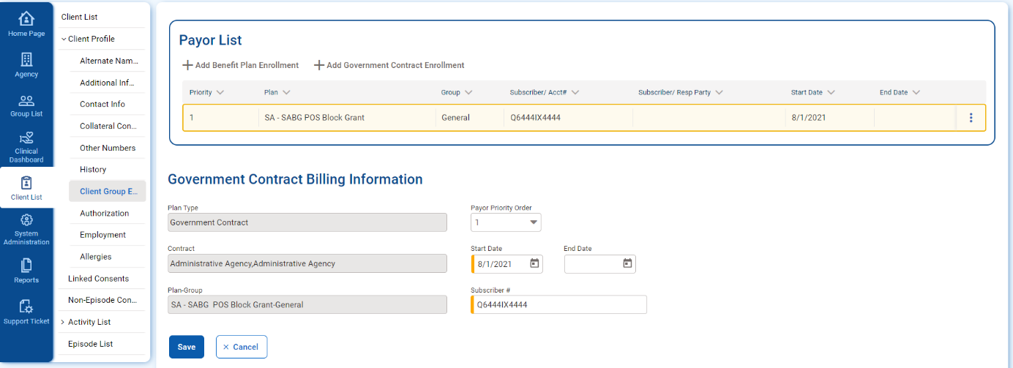
The Client Group Enrollment sub-menu displays a list of all Payor Plan/Groups to be selected as funding sources for billable encounters. This section lists the Plan, Group, Subscriber/Account#, Start Date of plan, End Date of plan, and Plan Type (Benefit Plan Enrollment or Government Contract Enrollment). If no plans are listed, you may select the Add Government Contract Enrollment link at the top-right of the Payor List section. This option will allow you to select from available contracts and plans/groups assigned to your agency. You will add the Government Contract Billing Information at the bottom of the screen. Select the Save button once completed.

Figure 1: Add Client Group - Government Contract Enrollment

Release Encounters to Billing
Required Role(s):
Release To Billing
Note: The Client Group Enrollment must be completed prior to releasing grant-billable encounters to billing in WITS.
When an encounter record is complete, it should be released to billing. To release an encounter, staff members must have the role “Release to Billing” assigned. Staff members with this role will have a link available in the Administrative Actions box on encounter screens.
Figure 2: Administrative Actions box, Release to Billing link
Administrative Actions are available on both the Encounter Profile screen and the Encounter Notes screen. Click the
Release to Billing link on either of these screens.
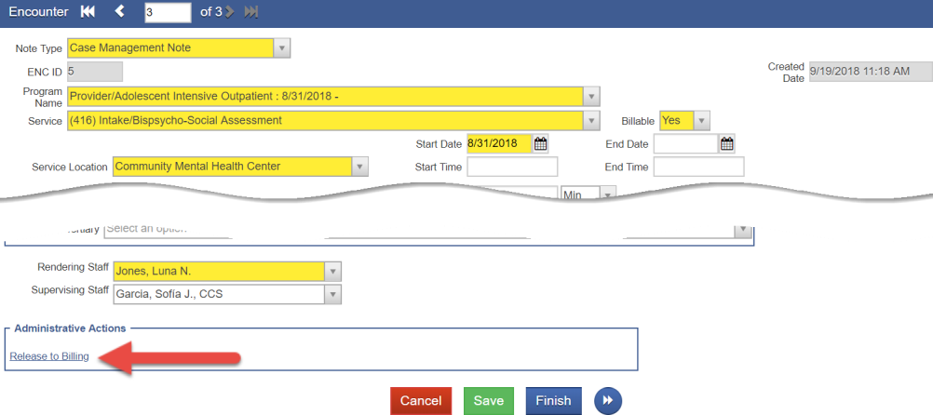
Figure 3: Encounter Profile screen, Release to Billing link
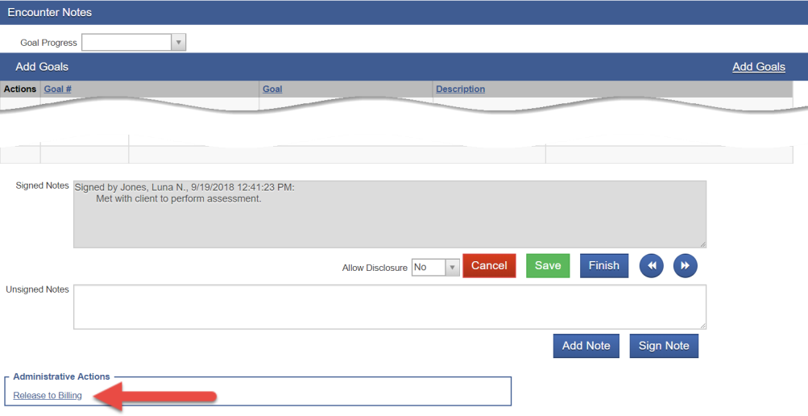
Figure 4: Encounter Notes screen, Release to Billing link

Agency Billing Process

Review and Adjust Claims
Where: Agency > Billing > Claim Item List

Once an Encounter is released to billing, it is now referred to as a “Claim Item”.

Required Role(s):
Create Agency Claim Batch Create Facility Claim Batches
- To view claim items, click Agency, then Billing, and then click Claim Item List. Note the Claim Item List will display
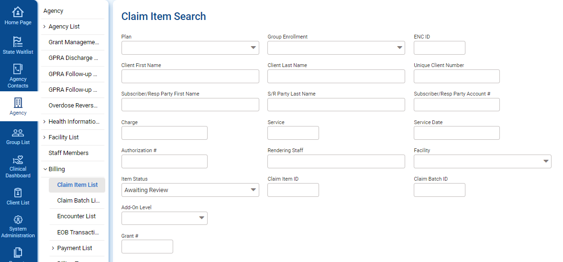
claim items with a status of “All Awaiting Review” by default.

Figure 5: Claim Item List screen
- Use the search fields to find a specific claim item or to filter your results, then click Search.
To view all available claim items, click Clear and then click Search.
- The claim item list will display the following information:
Table 1: Claim Item List information

Field | Description
Item # | Claim item number
Client Name | Name of client record
Grant # | Claim funding source / Grant
Service Date | Date of service
Service | Service code
Status | Status of claim item
Release Date | Date the claim item was released to billing
Charge | Total amount billed

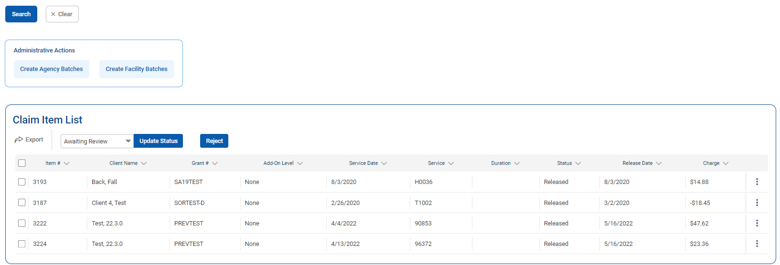
Figure 6: Claim Item List screen, Profile link
- Next, hover over the three dots (ellipsis) icon on the right of the claim item record and click on the Profile link.
- The Profile for Claim # screen displays all of the claim information and allows for claim item adjustments to be made if needed. Note you will only be able to edit a few active fields, as the remaining fields will be read-only.

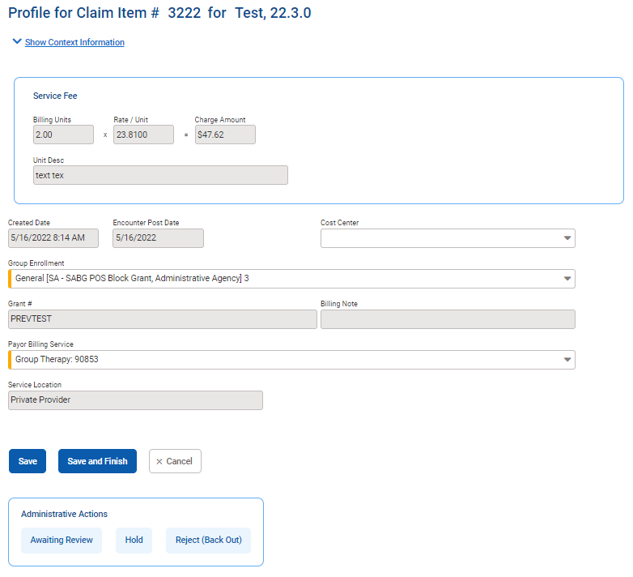
Figure 7: Profile for Claim # screen
- Next, you have the option of changing the claim item status. The Administrative Actions will vary based on the claim item status. If the claim item is Released, choose from the following actions In the Administrative Actions box:

Table 2: Claim Item Administrative Actions

Action | Description
Awaiting Review | This action link will indicate that the claim is awaiting review and approval to release.
Hold | This action link will indicate that the item is pending and is not ready to be batched and billed.
Reject (Back Out) | This action link will indicate that the claim item may not be billed.

- After selecting an Administrative Action, the browser window will reload, and the claim status is changed. Click Save and Finish to save and complete your action.

Note: Reversal and Adjustment
The reversal and adjustment claim items are automatically created with the released status. They will then be batched and billed when the next process runs.

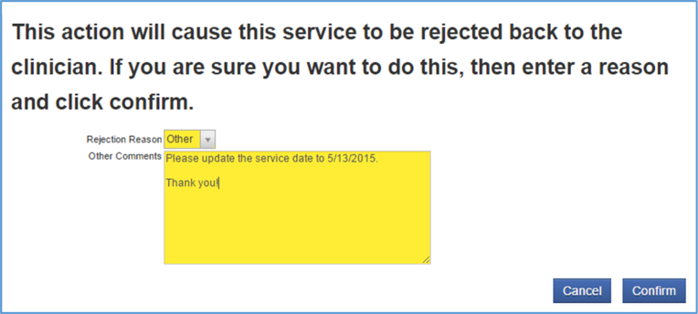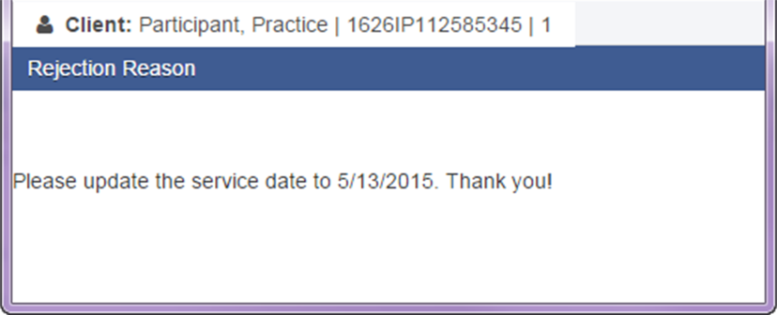Note: Reject (Back Out) a Claim Item
  - If rejecting a claim, another screen will appear and you will need to provide a reason.

Reject (Back Out) Claim Item Reason
Tip: A claim item with a Released status is ready to be batched and billed by the automated process.
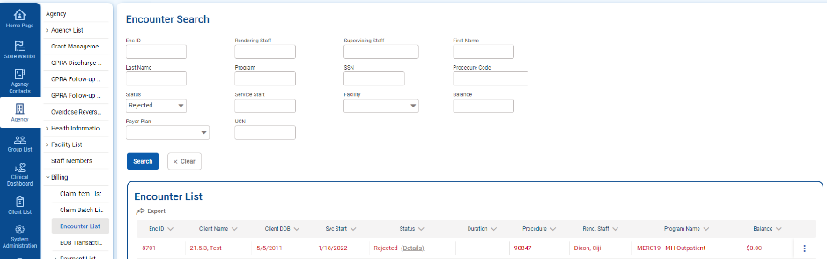
  - Once the claim is rejected, the encounter will appear in red on the encounter list.
Encounter List, Rejected Item in Red
  - The user will then be able to see the rejection reason by clicking the “Details” link. This link will open another window and will provide the user with information to make any changes.

Rejection Reason

Create Agency/Facility Claim Item Batches
Where: Agency > Billing > Claim Item List

Next, after reviewing all of the claim items, they will need to be batched. Batches can be made either for an agency or for a facility. This ability is assigned through the roles, Create Agency Claim Batch, and Create Facility Claim Batches.
For staff members with either of these roles, the Claim Item List screen will display an Administrative Actions box, with one or both of those links.
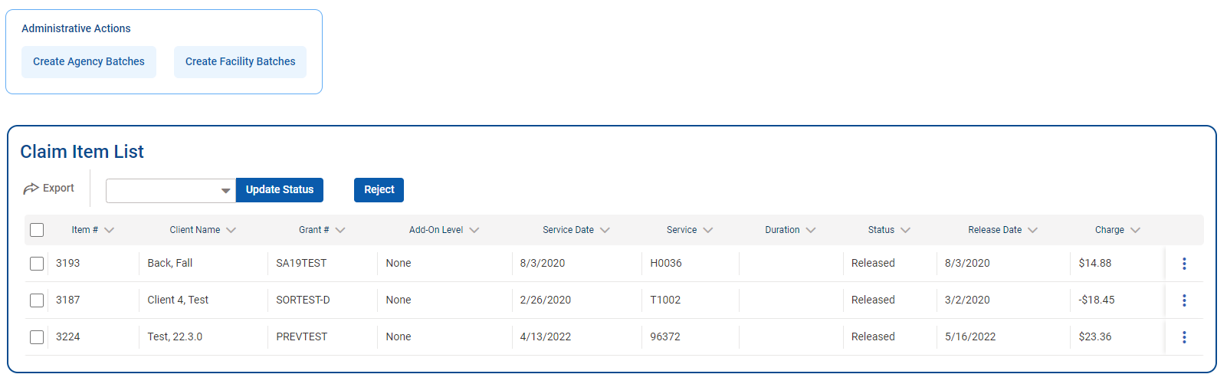
Figure 8: Claim Item List screen, Create Agency/Facility Batches
- To create an Agency and/or Facility Batch, click one of those links in the Administrative Actions box.
- On the Choose Plan(s) for Batching screen, select an available plan and move it to the “Selected Plans” box, and then click Go.
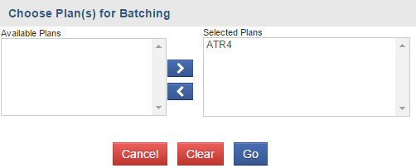
Figure 9: Choose Plan(s) for Batching screen
- A message will appear on the screen indicating that the claim items are being batched.
Figure 10: Batched Claim Items message
- Check the Claim Batch by clicking the Claim Batch List link in the left menu. See next section…

Claim Batch List
Where: Agency > Billing > Claim Batch List

The Claim Batch List screen allows you to review the Claim Batch profile, including all of the claim items associated with that batch, and then submit the claim batch to the payor for payment processing.
- From the left menu, click Agency, Billing, and then click Claim Batch List.
- Click Clear to remove pre-filled items in the search fields, and then click Search to view all of the claim batches.
- Hover over the ellipsis icon on the far right of the claim batch record and click the Claim Items link.

Figure 11: Claim Batch List, click Claim Items link
- The Claim Item List will then display all of the claim items associated with that batch. These can be reviewed before submitting the batch.

- On the Claim Batch List, review the batched claim item by hovering over the Actions column, and select the Profile
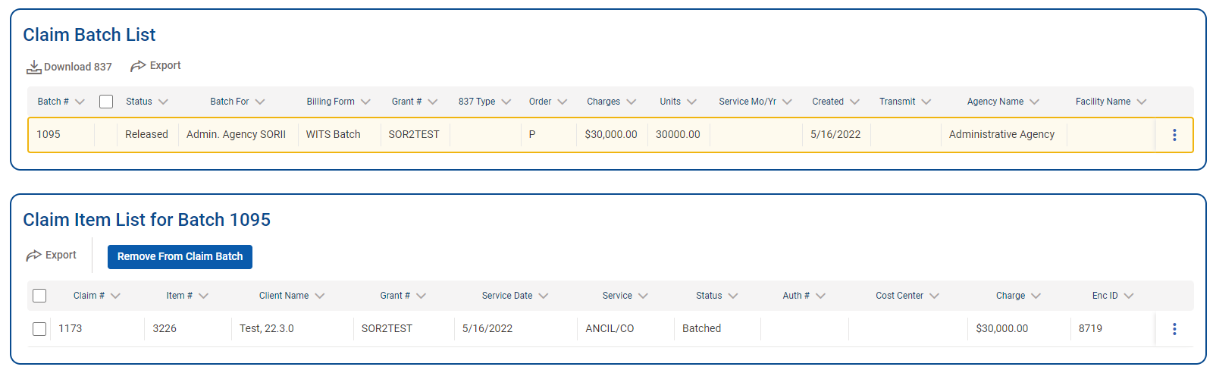
link.

Figure 12: Claim Item List and Batch List

- On the Profile screen of a Batched Claim Batch item, the Administration Actions box will display the following links:
Table 3: Provider Claim Batch Profile Administrative Actions
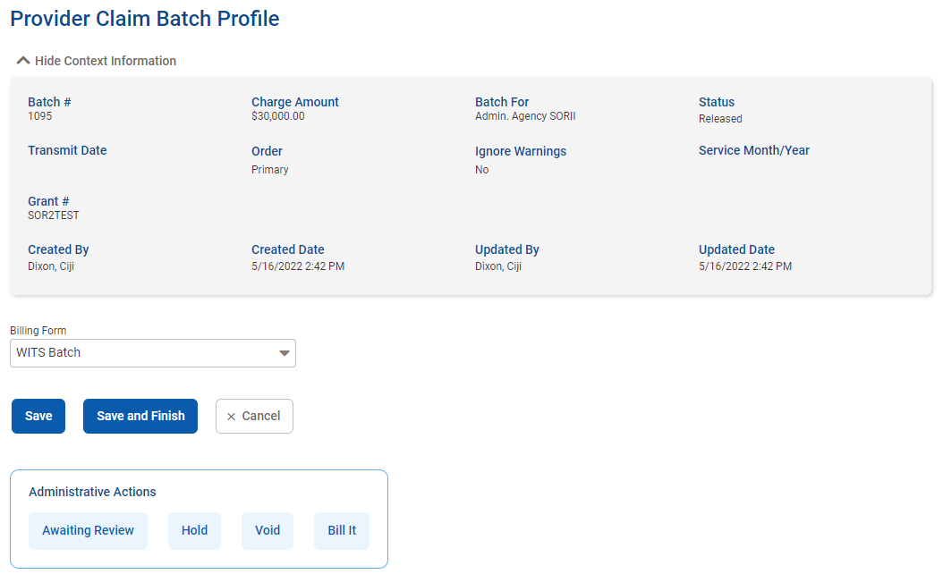
Administrative Action | Description
Awaiting Review | Indicates that the batch needs further review.
Hold | Indicates that the batch is pending and is not ready to be billed.
Void | This will void the batch.
Bill It | This will submit the batch for the Contractor agency (payor) for payment processing; the status of the claim batch will be updated once the payor accepts the batch and approves for payment.

Figure 13: Provider Claim Batch Profile, Administrative Actions links
- Click any of the links in the Administrative Actions box, and then click Finish. This will return to the Claim Batch List screen.
- If viewing the Profile of Batched Claim Item that has been fully adjudicated by the payor, the following actions will be available in the Administrative Actions box:
Table 4: Reverse and Adjust Administrative Actions

Administrative Action | Description
Reverse | This selection will create a reverse transaction of the original claim item; The charge will appear as a negative amount on the Claim Item List screen.
Adjust | This selection will create a reverse transaction of the original claim item as well as a new claim corresponding to the adjustment you just entered; The Claim Item List screen will then show two claim items: negative charge and the adjusted amount.

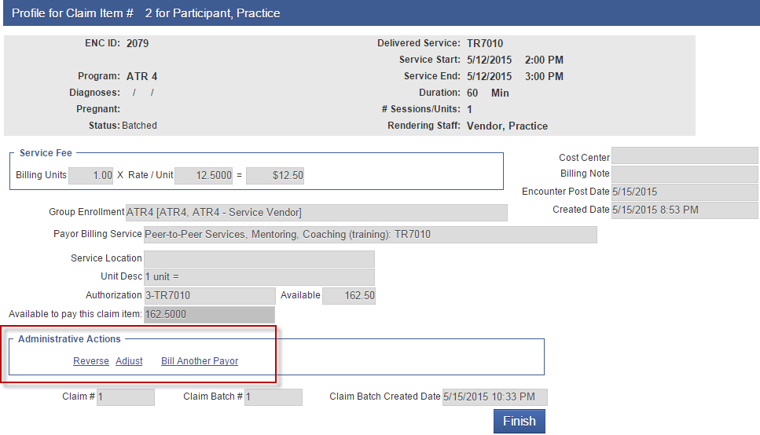
Figure 14: Accepted Claim Batch, Profile link of Claim Item
- Clicking “Reverse”, or “Adjust”, will open a confirmation screen. Click Yes to continue.
- Complete your selection by clicking Finish to go back to the Claim Item List screen.

Tip: When the intake is closed, all of the authorizations related to this intake are closed. You may re-
open the intake if necessary. You need to be granted the “Case Reopen” role to do so.

