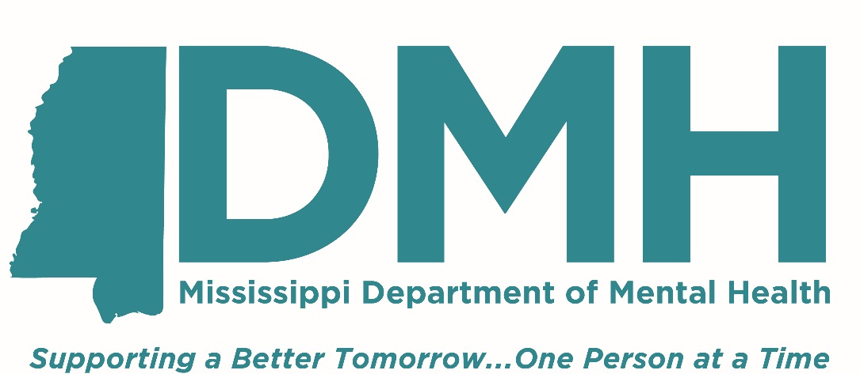

Mississippi Department of Mental Health

Division of Outreach and Training

**Statewide Fentanyl and Drug Abuse Education, Prevention and Cessation Program**

**Competitive Grant**

Funding Opportunity Announcement

Application Due Date: December 8, 2023

**State** **of** **Mississippi**

**Fentanyl and Drug Abuse Education, Prevention and Cessation Program**

The Mississippi Department of Mental Health (DMH) is committed to providing a person-centered, recovery-oriented system of care for all Mississippians in need of mental health, ID/DD, and substance use services. This funding will allow for the development and implementation of a statewide fentanyl and drug abuse education, prevention, and cessation program. During the 2022 Legislative Session, the legislature passed House Bill 231 that directs the Mississippi Department of Mental health to develop and implement a comprehensive statewide fentanyl and drug abuse education, prevention and cessation program that is based on scientific data and research that have been shown to be effective at accomplishing at a minimum:

* Materials, curricula and programs that may be used or implemented in schools and other locations to educate youth about fentanyl and other harmful drugs and to discourage the use of fentanyl and abuse of other drugs, including, but not limited to, materials, curricula and programs that involve youth, educate youth about health hazards from the use of fentanyl and abuse of other drugs, help youth develop skills to refuse fentanyl and other harmful drugs, and demonstrate to youth how to stop using fentanyl and abusing other drugs;
* Local community programs, including, but not limited to, youth-based partnerships that discourage the use of fentanyl and abuse of other drugs and involve community-based organizations in fentanyl and drug abuse education, prevention and cessation programs in their communities;
* Programs to assist and help people to stop using fentanyl and/or abusing other drugs;
* A surveillance and evaluation system that monitors program accountability and results, produces publicly available reports that review how monies expended for the program are spent ,and includes an evaluation of the program’s effectiveness in reducing and preventing the use of fentanyl and abuse of other drugs, and annual recommendations for improvements to enhance the program’s effectiveness.

Please note that all grants are contingent on the funding by the Mississippi State Legislature and/or the Federal Government. The submission of this application to the Department of Mental Health is not a guarantee of funding. Program data will be monitored and evaluated on a monthly basis. Please note that the expectation is data will be public and published on the DMH website.

**DMH is now accepting funding applications for a 6-month cycle ending June, 2024, at an award of $700,000.**

1. **Application** **Guideline** **Requirements:** **Please** **submit** **the** **following** **required** **forms** **which** **can** **be** **found** **in** **the** **MS** **Department** **of** **Mental** **Health’s** **Service** **Provider** **Manual.**

1. Proposed Budget Summary Form: 100-1

2. Proposed Budget Personnel Form: 100-2

3. Proposed Budget Line-Item Form: 100-3

4. Budget Narrative/Justification.

5. Program Narrative (not to exceed 3 pages) which addresses B – E.

1. **Outcome** **Measures**

1. **Goals and/or objectives for first year funding of this program.**

**a. Describe how your proposal will meet each goal/objective.**

**b. Describe how you plan to evaluate the effectiveness of each action**.

**Goals**

1. To implement three pilot fentanyl and drug abuse education, prevention and cessation programs in schools throughout the state by the end of the first year.
2. To discourage the use of fentanyl and abuse of other drugs among youth involved in pilot programs.
3. To increase knowledge of the health hazards from the use of fentanyl and abuse of other drugs, help develop skills to refuse fentanyl and other harmful drugs, and increase knowledge of youth on how to stop using fentanyl and abusing other drugs.

**Performance Measures**

* Number of task force meetings
* Number of successful pilots implemented at schools
* Number of students participating in pilot programs each year
* Demonstrated surveillance and evaluation system that monitors program accountability and results
* Statewide reduction of fentanyl and abuse of other drugs

**Reporting on Performance Measures**

DMH grant recipients must review the performance data they submit to DMH,

assess their progress, and use this information to improve the management of

their grant. Recipients are also required to report on their progress addressing the goals and objectives identified in the grant. The assessment should be designed to help you determine whether you are achieving the goals, the objectives, and outcomes you intend to achieve and whether adjustments need to be made. You will be required to submit a monthly report on performance measures in your grant when you submit your cash request. Performance measures will be evaluated by the Department of Mental Health each month.

1. **Specific Requirements**
2. **Describe how you will implement the specific requirements of this grant**
3. **Describe how you plan to evaluate the effectiveness of each action.**
4. Facilitate HB231 Task Force meetings at a frequency that meets the requirements of fulfilling the purpose of the legislation, but at a minimum of one per month. Meetings may be held virtually and should promote open communication and discussion of ideas.
5. Present materials, curricula, and programs that have been used successfully and are based on scientific data and research in other states.
6. Utilizing feedback from the task force, select materials, curricula, and programs to implement in Mississippi.
7. Develop school pilot program using the selected curricula, materials and/or programs selected by the Task Force.
8. Implement the pilot program in three Mississippi schools.
9. Develop a local community program that includes youth-based partnerships that discourage the use of fentanyl and abuse of other drugs that involve community-based organizations in fentanyl and drug abuse education, prevention, and cessation programs in at least one community. If funding is sufficient after the implementation of three school programs, implement the local community program in at least one community.
10. Develop comprehensive referral and resource guide for schools that provide resources and programs to assist and help people stop using fentanyl and/or abusing other drugs.
11. Develop and implement a surveillance and evaluation system that monitors program accountability and results, produces publicly available reports that review how monies ex pended for the program are spent, and includes an evaluation of the program’s effectiveness in reducing and preventing the use of fentanyl and abuse of other drugs, and annual recommendations for improvements to enhance the program’s effectiveness.

**G.** **Other** **Guidelines:**

1. Any travel reimbursement listed in the budget cannot exceed the current State of Mississippi reimbursement rate (currently $0.65 per mile.)
2. Indirect/administrative costs listed in the budget cannot exceed 8% of the budget total.

4. Provide a list of staff from the Proposed Budget Personnel Form 100-2 which also provides a portion of their time to other grant funded services, to include the grant funded service, the position the staff holds, and the percentage of time the staff will be providing the other service(s).

5. Data reports required by this funding must be submitted monthly by the 10th of the following month.

**H.** **Required** **Data** **Report(s):**

1. Progress on performance measures and implementation of required services.

2. The Data Report must be submitted via email to Courtney Littleton at [courtney.littleton@dmh.ms.gov](mailto:courtney.littleton@dmh.ms.gov) by the 10th of every month for the month just ended.