
SAMHSA Grant Management
SUPRT Assessments User Guide
Version 1.0

Prepared by FEI Systems

Date 2/13/2026

Table of Contents
Record of Changes 1
1. Introduction 2
1.1. Purpose 2
1.2. Audience 2
2. SUPRT Assessments 2
2.1.1. SUPRT Assessment Types 3
2.1.2. SUPRT-A Assessment 3
2.1.3. SUPRT-C Assessment 4
2.2. Transitioning from GPRA to SUPRT Tools 5
2.2.1. How do I access the SUPRT-A and -C assessments? 7
2.2.2. How do I complete the assessments? 9
3. Items of Note 13
3.1. General Information 13
3.2. SUPRT-A Assessment 14
3.3. SUPRT-C Assessment 14
4. Frequently Asked Questions 14

List of Tables
Table 1: Record of Changes 1
Table 2: SUPRT-A Sections 3
Table 3: SUPRT-A Required Sections By Assessment Type 4
Table 4: SUPRT-C Assessment Version by Age-Group 5

List of Figures
Figure 1: Updated Grant Management Workflow 2
Figure 2: Navigate to Expired GPRAs 6
Figure 3: Completed and Accepted GPRA 6
Figure 4: Accessing/Creating Client Record 7
Figure 5: Navigating to SUPRT Assessments 8
Figure 6: Accessing SUPRT Assessments 8
Figure 7: Add SUPRT Assessment 9
Figure 8: SUPRT Workspace 10
Figure 9: Accessing Assessment Section 10
Figure 10: Completing Assessment Section 11
Figure 11: Complete Section of Workspace 12
Figure 12: Confirmation Window 12
Figure 13: Completed Assessment 13
Figure 14: Assessment List and Statuses 13

Record of Changes
Table 1: Record of Changes
Version Number | Date | Author/Owner | Description of Change
0.1 | 2/12/2026 | Scott Wilson | Initial Draft

Introduction
SAMHSA has announced the launch of the SAMHSA Unified Performance Reporting Tools (SUPRT), which will replace existing client-level data collection instruments (GPRA) currently used by SAMHSA discretionary grantees.
This guide is intended to assist WITS Grant Management customers that are transitioning from the GPRA tool to the new SUPRT-A and SUPRT-C tools.

SUPRT Assessments
As shown in the figure below, no changes to the overall Grant Management workflow have been made.
NOTE: Some states may have additional steps in their Grant Management workflow. If you have any questions about your workflow, reach out to your state administrators for clarification.
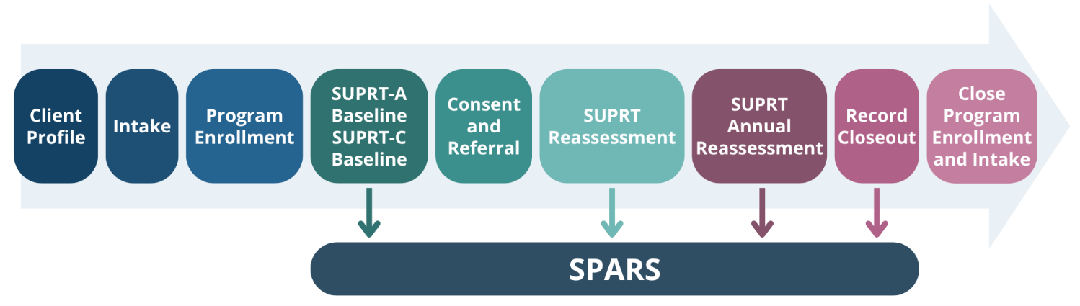
Figure 1: Updated Grant Management Workflow

SUPRT Assessment Types
Similar to the GPRA Intake, Follow-Up, and Discharge, the new SUPRT Tool has several assessment types:
- Baseline: Baseline assessments should be completed 30 days before or after the client first receives services. Clients can receive multiple baseline assessments for episodes of care under the same grant.
  - Multiple baselines could occur if the client relapses after treatment, or if the client leaves or never starts treatment and returns at a later date.
- Reassessments: Reassessments are due either 3 or 6 months after the Baseline Assessment. The window to complete this assessment is 30 days before and after the baseline assessment anniversary.
  - NOTE: When this reassessment is due may vary by state. Reach out to your state administrator if there are any questions regarding when this reassessment is due.
- Annual: Annual Assessments are due 365 days after the Baseline Assessment, and every 365 days thereafter. The window to complete this assessment is 30 days before and 30 days after the baseline assessment anniversary.
- Closeout: Closeout assessments are done when the client is no longer receiving services in a grant program. This assessment must be completed within 30 days of the date when services were discontinued.
  - Once a closeout is completed, the reassessment or annual assessment is no longer required, even if within the window for completing these assessments.
  - If the client returns for care, a new Baseline assessment should be completed.

SUPRT-A Assessment
The SUPRT-A assessment, completed by providers, gathers previously collected information about the client’s behavioral health history, screenings, diagnoses, services received, and demographic details. This is not an assessment that is conducted face to face with the client, rather the information should be sourced from the client’s existing records. The tool is designed to support the collection and reporting of client-level service data at baseline, reassessment, annual, and closeout intervals. SUPRT-A is to be completed by the grantee at each assessment type and is required for all clients receiving services under the grant.
The SUPRT-A assessment is divided into six sections. The table below describes each section.
Table 2: SUPRT-A Sections
Assessment Section | Description
A. Record Management | Collects Administrative details like the Client ID, Grant ID, Date of assessment, etc.
B. Behavioral Health History | Client’s insurance type, acute services utilized in the past 30 days, and justice system involvement in the past 90 days.
C. Behavioral Health Screenings | Client’s screening or assessment results in the past 30 days.
D. Behavioral Health Diagnosis | Client’s current behavioral health diagnosis, and other health conditions.
E. Services Received | Information about services provided through the grant. This section is not available for the Baseline assessment.
F. Demographics | Client’s demographic information, including race/ethnicity, and sex. This section is only collected for the Baseline assessment.  NOTE: This section is required if the client declines to complete the SUPRT-C assessment.

Depending on the assessment type, not all sections of the SUPRT-A may be required. Reference the table below for which sections are required for each assessment type.
Table 3: SUPRT-A Required Sections By Assessment Type
SUPRT Section | Baseline | Reassessment | Annual (Adult Only) | Closeout
Record Management | Yes | Yes | Yes | Yes
Behavioral Health History | Yes | Yes | Yes | No
Behavioral Health Screenings | Yes | Yes | Yes | No
Behavioral Health Diagnosis | Yes | Yes | Yes | No
Services Received | No | Yes | Yes | Yes
Demographics | Yes | No | No | No

SUPRT-C Assessment
SUPRT-C is an assessment, completed by the client, that includes sections that standardize data about the client, including Record Management, Demographics, Social Drivers of Health, and Client-Reported Core Outcomes. Detailed information related to this assessment tool can be found later in this document.
Depending on the client’s age at baseline, there are different versions of the SUPRT-C assessment. The version given to the client at baseline is used throughout the client’s episode of care, even if the client would later be in a different age group.
Example: The client is 17 years old at baseline. The Youth (12-17 years) is given at baseline and reassessment, even if the client turns 18 one month after the baseline is recorded.
Depending on the SUPRT-C assessment version, it can be completed by the client, proxy, caregiver, or parent.
In addition, the SUPRT-C assessment is only given at certain points depending on the client’s age. The table below provides information on the different versions of the SUPRT-C assessment as well as who may complete the SUPRT-C assessment, which assessment types are required based on the client’s age group.
NOTE: The SUPRT-C annual assessment is only required for the adult version.
NOTE: The SUPRT-C does not populate on the closeout assessment.
Table 4: SUPRT-C Assessment Version by Age-Group
Age-Group | Respondent Type | Assessment Point
Adults (18+ years) | Client (or proxy) | Baseline
Adults (18+ years) | Client (or proxy) | Reassessment
Adults (18+ years) | Client (or proxy) | Annual
Youth (12-17 years) | Client (or proxy) | Baseline
Youth (12-17 years) | Client (or proxy) | Reassessment
Child (5-17 years) | Caregiver/Parent | Baseline
Child (5-17 years) | Caregiver/Parent | Reassessment

The SUPRT-C assessment is comprised of four sections. The table below identifies who completes each section and when the section is completed.
Table 5: SUPRT-C Sections
SUPRT-C Section | Completed By | Assessment Point
Record Management | Grantee | At all assessment points (except closeout) for all age groups.
Demographics | Client/Proxy/Caregiver/Parent | Baseline only for all age groups.
Social Drivers of Health | Client/Proxy/Caregiver/Parent | Baseline and reassessment for all age groups.
Client Reported Core Outcomes | Client/Proxy/Caregiver/Parent | At all assessment points (except closeout) for the adult version only.

Transitioning from GPRA to SUPRT Tools
FEI estimates that the SUPRT assessments and updated grant episode workflow will be included in the February Release. In parallel, we will be working on the CSV Batch Upload functionality (release TBD).
Of note, if the GPRA was previously completed for a client:
- The SUPRT baseline assessment is not completed unless a new episode of care is opened for the client.
- The SUPRT-C assessment is not required for any assessment period during the client’s current episode of care.
- The reassessment and annual SUPRT-A assessments will be completed within their respective anniversary windows based on when the initial GPRA intake was completed.
- The SUPRT-A closeout assessment will be completed when the client is no longer receiving services.
If you are unsure that a GPRA intake has been completed or to review previously completed GPRAs, navigate to Client List > Activity List > Expired GPRAs.
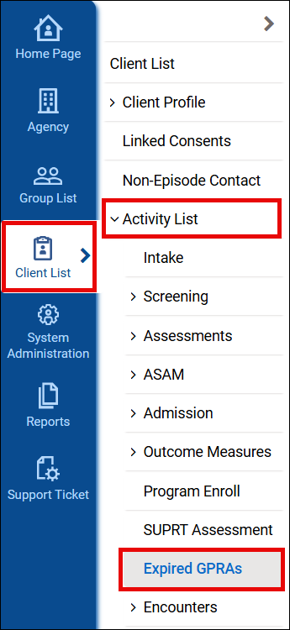
Figure 2: Navigate to Expired GPRAs
Here all previously created GPRAs will display, even those that were not completed. To determine if the intake was completed, look for the following:
- Interview Type – Intake
- Record Status – Completed
- SPARS Upload Status – Accepted
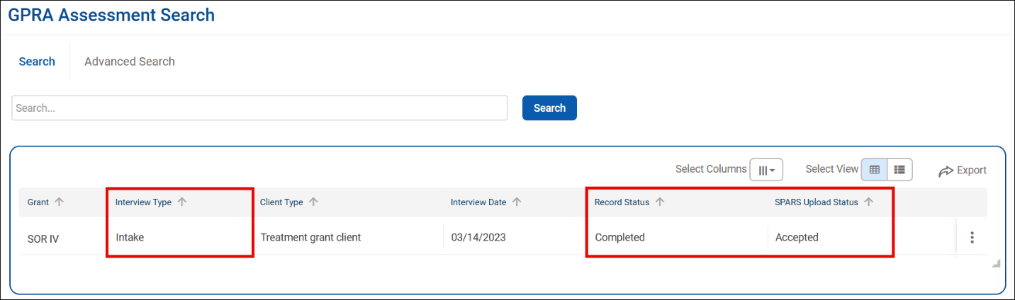
Figure 3: Completed and Accepted GPRA
If the intake does not show the statuses completed and accepted, then the baseline SUPRT assessments are required.
The following sections provide information on how to access and complete the SUPRT assessments.

How do I access the SUPRT-A and -C assessments?
- Create a client record and follow the state defined process for starting an episode of care and enrolling the client in a SAMHSA supported grant program.
  - If unsure if a program is linked to a SAMHSA supported grant, reach out to your leadership or agency administrator.
  - If the client already exists, access the record. If needed, open a new episode of care and enroll the client in a SAMHSA supported grant program.
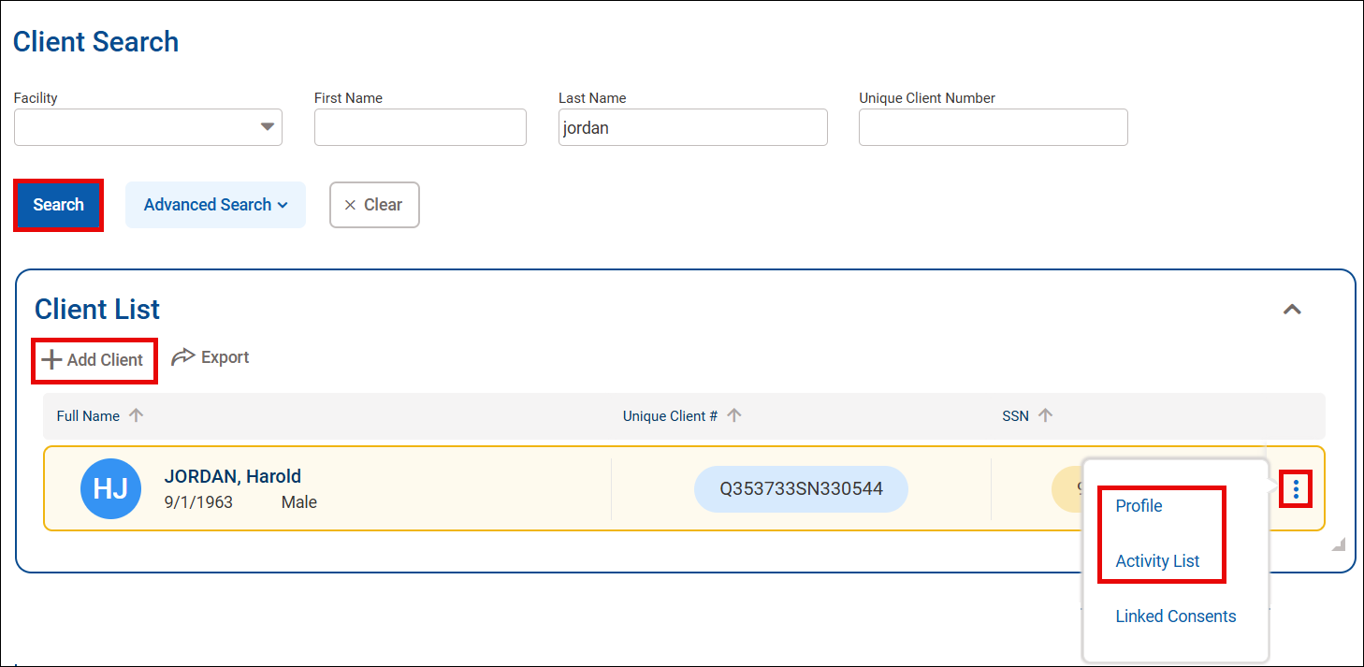
Figure 4: Accessing/Creating Client Record
- From the Client List menu click Activity List and then SUPRT Assessment.
  - SUPRT Assessment is located below the Program Enroll submenu option.
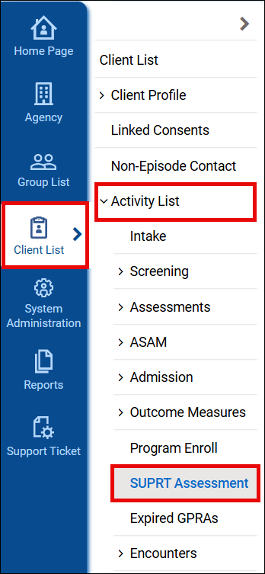
Figure 5: Navigating to SUPRT Assessments
- To create a new SUPRT Assessment, click +Create New SUPRT Assessment in the upper right of the SUPRT Assessment window.
  - If accessing an existing assessment, hover over the vertical ellipsis to the right of the assessment in question and click Edit.
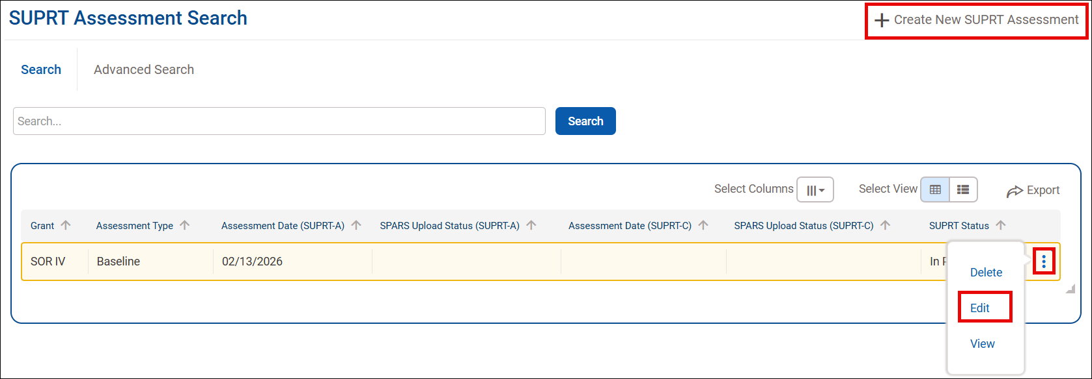
Figure 6: Accessing SUPRT Assessments
- Add SUPRT Assessment window displays for new assessments. Complete the fields and click Save.
  - Assessment Type has 4 options:
    - Baseline – Completed at the start of services.
    - Reassessment – Completed once at the 3 to 6 month anniversary from the baseline assessment date.
    - Annual – Completed every 12 months after baseline assessment.
    - Closeout – Completed when the client discontinues grant services.
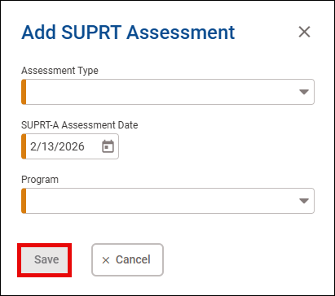
Figure 7: Add SUPRT Assessment

How do I complete the assessments?
From within the SUPRT Assessment:
- If Edit (not Done Editing) displays in the upper right of the window, click it to allow changes to be made to the assessments.
- Navigate to each section by scrolling, clicking on the section from the SUPRT Overview list, or clicking on a Completion Requirement.
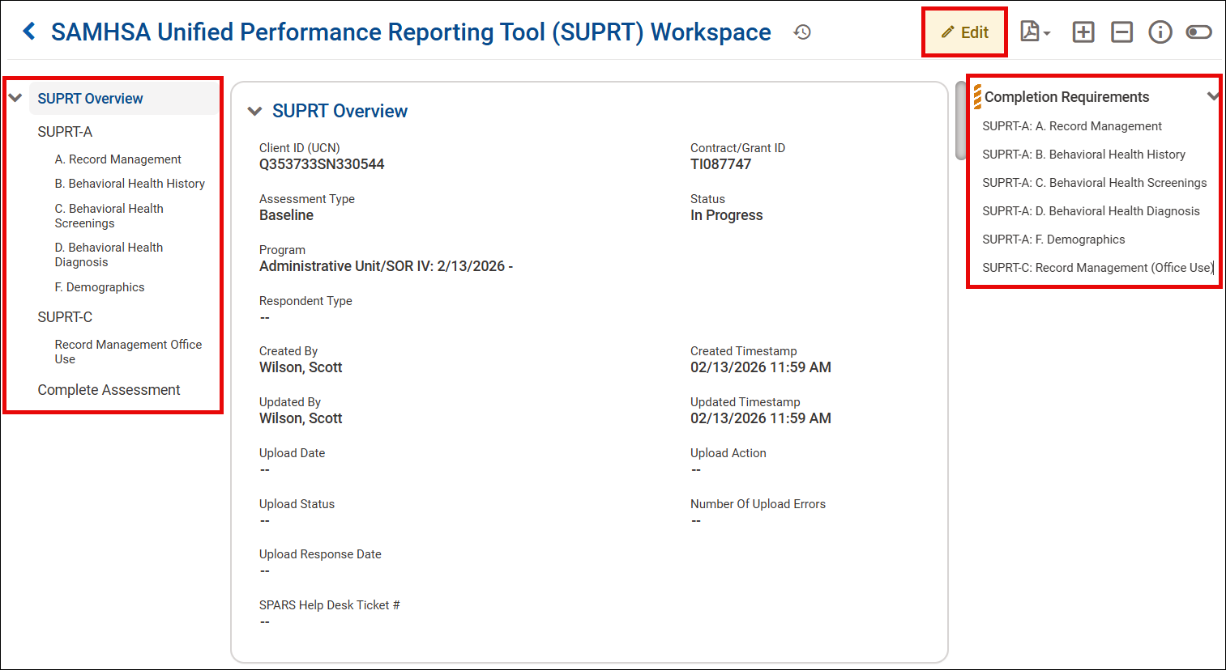
Figure 8: SUPRT Workspace
- To edit a section of the assessment, hover over the section and click the pencil icon in the upper right of the section.
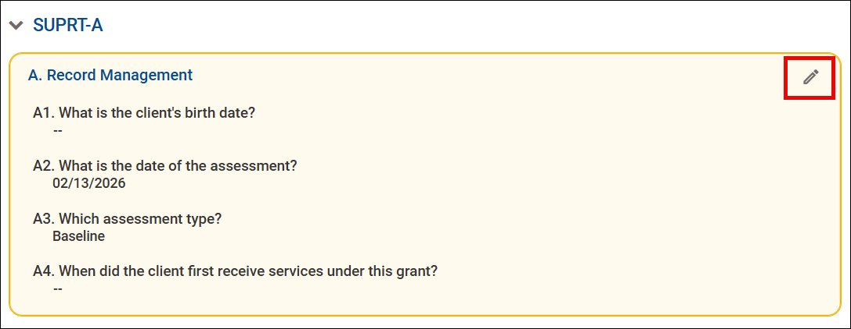
Figure 9: Accessing Assessment Section
- A window for the section will open. After answering all questions for the section, click Save to save your responses and close the window.
  - Click on the pencil icon for each section and answer all questions.
  - Once all questions have been answered in a section, the section will be removed from the Completion Requirements list.
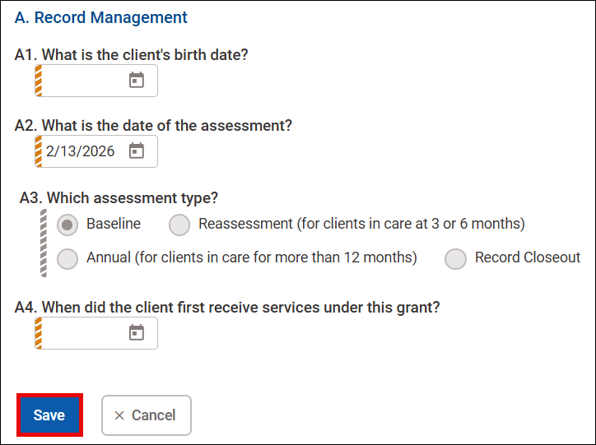
Figure 10: Completing Assessment Section
- Once both assessments have been completed, the Completion Requirements on the right will no longer display, and you will see the Complete button at the bottom of the workspace. Click it to complete the assessments.
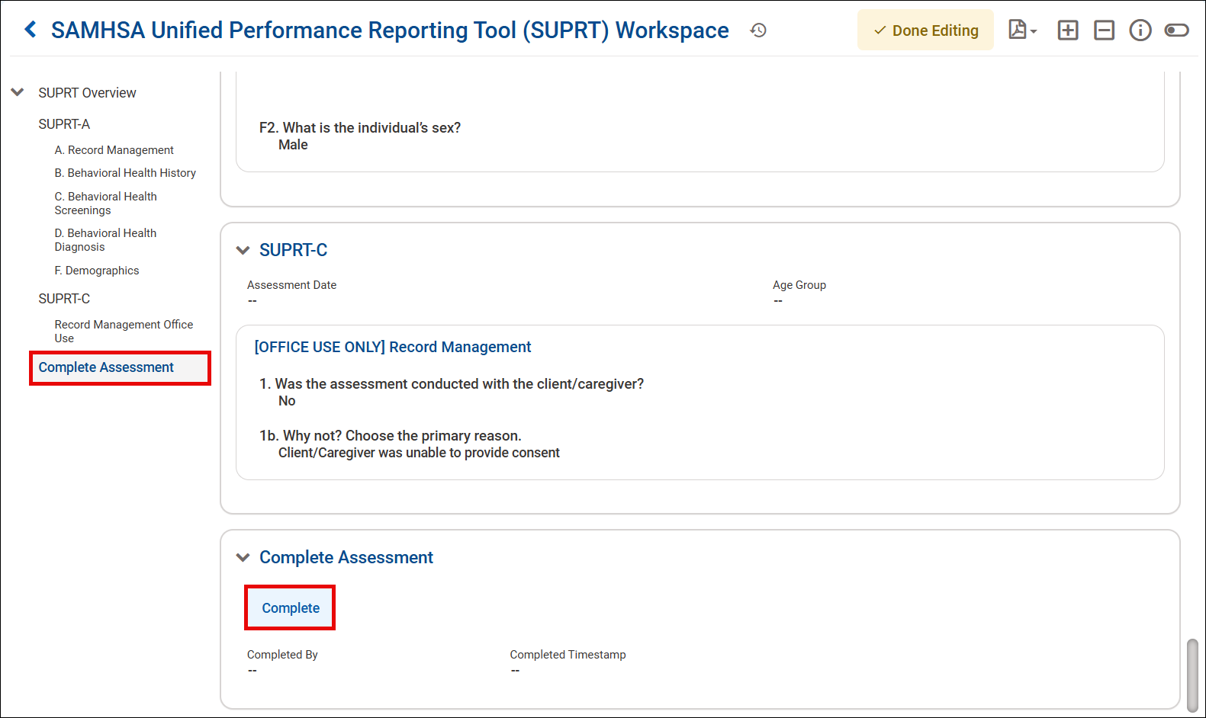
Figure 11: Complete Section of Workspace
- A confirmation window will display. Click Ok.
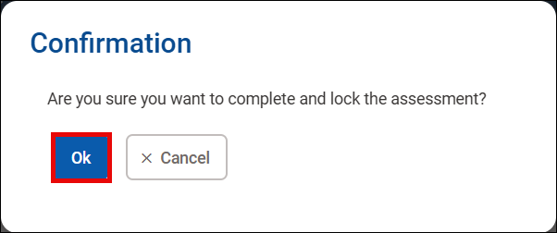
Figure 12: Confirmation Window
- The assessment will now be locked, and…
  - The status will show Complete.
  - Your name and the date the assessment was completed will be added to the Complete Assessment section.
  - Instead of Complete, you will see an Unlock button. Just like with the GPRA, the SUPRT assessments can be edited until they are transmitted and accepted by SPARS.
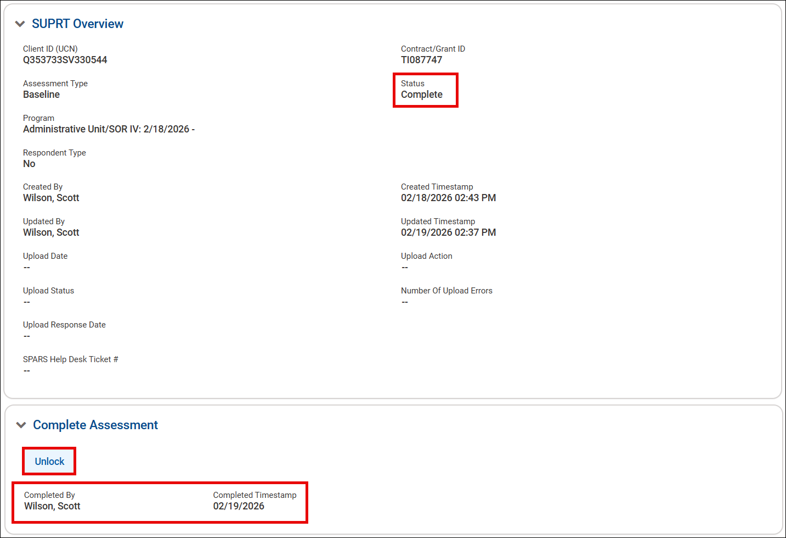
Figure 13: Completed Assessment
Back on the SUPRT Assessment List screen, the completed assessment will be displayed with a SUPRT Status of Complete. Once the assessments are transmitted and accepted by SPARS, those fields will populate as well. Just like with the GPRA, you want Accepted for the SPARS Upload statuses.
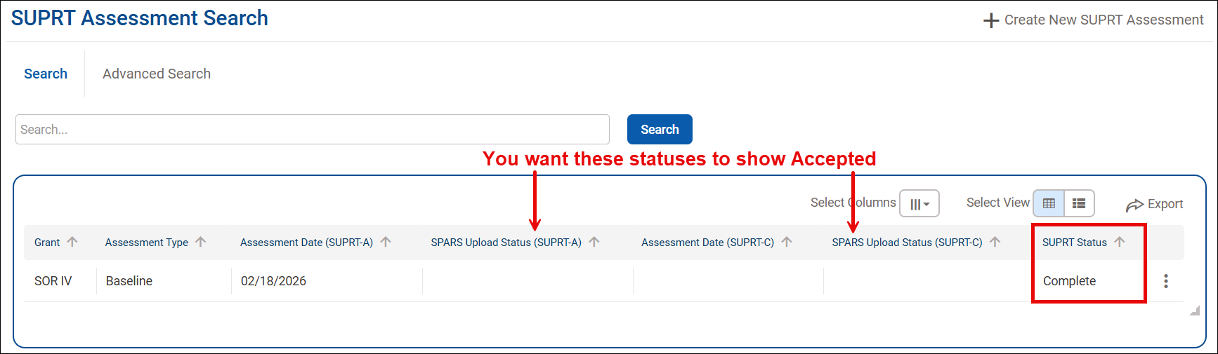
Figure 14: Assessment List and Statuses

Items of Note

General Information
- Save often to ensure work is not lost.
- Check boxes allow for multiple answers to a question.
- Radio buttons only allow for a single answer to a question.
- If a client returns after a closeout assessment is completed, a new baseline assessment must be completed.

SUPRT-A Assessment
- SUPRT-A is completed by grantee staff.
- SUPRT-A is mandatory and must be completed for each assessment period.
- Section F – Demographics is only completed if the client/caregiver/parent declines to complete the SUPRT-C baseline assessment.

SUPRT-C Assessment
- SUPRT-C Record Management is mandatory and completed by the provider agency.
- Client/caregiver/parent completion of SUPRT-C is voluntary.
- SUPRT-C must be offered for each assessment period, even if it was previously declined.
- SUPRT-C is not completed for closeout assessments.
- The SUPRT-C has specific versions based on age categories.
  - The age category selected at baseline is used for all reassessments throughout the client’s episode of care.
  - If the client’s age would place them in a new age category, the SUPRT-C age specific version remains the same as the one used at baseline.
- The SUPRT-C Annual assessment is only completed for those in the Adult category at baseline assessment.
- Select Missing if a question is not answered.
- If “Prefer not to answer” was a selected response and other responses given for the question, record only “Prefer not to answer.”
- Select Invalid Response if the client answers the question incorrectly. For example, giving two responses for a question when only one is allowed.

Frequently Asked Questions
When does SUPRT assessment need to be completed?
  - Baseline assessments must be completed within 30 days before or after the client receives their first SAMHSA grant supported service.
  - 3 or 6 Month Reassessments are completed within 30 days before or after the 3 or 6 month anniversary of the baseline’s completion.
  - Each Annual Reassessment (SUPRT-A and SUPRT-C Adult only) is completed within 30 days before or after the 12 month anniversary of the baseline’s completion.
  - Closeout assessment is completed when the client discontinues SAMHSA grant supported services.
- If the client discontinues services before the 3-6 Month or Annual Reassessments, do I still need to complete them?
  - No. Only the Closeout Assessment is required.
- What happens if the client returns for services after the closeout assessment is completed?
  - A new baseline and subsequent assessments are required.
- How do I answer a question in the SUPRT-A if the information is not available?
  - Select the option, “Not documented in records or not documented in records using this standard.”
- The SUPRT-C assessment was only partially completed. Do I need to complete the SUPRT-A Demographics (F) section?
  - No. If the client/caregiver/parent completed any part of the SUPRT-C assessment, then the SUPRT-A Demographics (F) section is not completed.
- Do the SUPRT-A and SUPRT-C assessments need to be completed at the same time?
  - No. Grantees have a 60-day window for completing the assessments. However, the grantee will not be able to submit the assessments until required data for A and C are entered.
- Why is a section still showing in the Completion Requirements section of the SUPRT Tools Workspace?
  - It is because one or more questions have not been answered for the section.
- What happens if an assessment is completed outside of the window?
  - The assessment will still be uploaded to SPARS. However, the assessment will not count towards your reassessment completion rates.

